LAKBAY: HISTORY-THEMED 2D SIDE SCROLLING ADVENTURE GAME

# DYLAN R. JABLA

# FRAN KYLE A. LEDESMA

# LAILLE ALDRICH P. RODIL

# NICHOLE ANDREA P. ROSARIO

# 

# A Thesis Proposal

# Presented to the Faculty of the

# Computer Studies Department

# College of Science

# Technological University of the Philippines

Ayala Blvd., Manila

In Partial Fulfillment

of the Requirements for the Degree

Bachelor of Science in Computer Science

May 2023

**ABSTRACT**

The Study, LAKBAY: HISTORY-THEMED 2D SIDE SCROLLING ADVENTURE GAME, aims to provide its players a fun, new, and interactive way of learning history through a more modern medium of gaming. Using an interesting story, entertaining gameplay and fun music and art, players are able to learn about history. It features 1 playable character and 5 playable levels, each set in a different point in Philippine history with different enemies, goals, and objectives. The game was developed using Unity Game Development for most of the development, which uses C# for most of the backend code such as the physics of the characters and the enemies inside the game. It was made to be played on machines that run the Windows Operating System from Windows 7 to the latest Windows 11. Test results show that the game could run successfully and performed as it should without any incompatibility problems. The system was tested by 30 evaluators using the standard criterion of ISO 25010 to check for the quality of the software and was rated with an overall rating of 3.49 and a descriptive rating of "Very Good".

# TABLE OF CONTENTS

**PRELIMINARIES Page**

Title Page 1

Table of Contents 2

List of Tables 4

List of Figures 5

List of Appendices

**CHAPTER 1: THE PROBLEM AND ITS SETTING 6**

Background of the study 6

Objectives of the Study 7

Scope and Limitations of the Study 8

Significance of the Study 8

**CHAPTER 2: CONCEPTUAL FRAMEWORK 9**

Review of Related Literature 9

Conceptual Model of the Study 21

Operational Definition of Terms 23

**CHAPTER 3: METHODOLOGY 24**

Project Design 24

Project Development 31

Operation and Testing Procedure 32

Evaluation Procedure 33

**REFERENCES 25**

# 

**LIST OF TABLES**

|  |  |  |
| --- | --- | --- |
| **Table** | **Title** | **Page** |
| 1 | Game Elements of the study of (Kusuma, et al, 2021) | **31** |
| **2** | Normality Test Result | **32** |
| **3** | Key Benefits and Description | **38** |
|  |  |  |
|  |  |  |
|  |  |  |
|  |  |  |

**LIST OF FIGURES**

|  |  |  |
| --- | --- | --- |
| **Figure** | **Title** | **Page** |
| 1 | Image of Mario’s in-game sprite and the image of the beginning map of Super Mario | **14** |
| 2 | Image of Flappy Bird | **16** |
| 3 | Simple Level Design Drawing by Game Designer | **40** |
| 4 | Microsoft Excel Map Format | **42** |
| 5 | Coloring Process of the Game’s Setting | **42** |
| 6 | Helion District Final Layout | **44** |
| 7 | Character Sprite of Awang | **45** |
| 8 | A* Algorithm | **48** |
| 9 | Conceptual Model of the Study | **51** |
| 10 | Game Design | **55** |
| 11 | Visualization of A* Algorithm. | **61** |
| 12 | Application of the pathfinding | **62** |
| 13 | Visual Table of Content Design | **63** |
| 14 | Escolta St., Manila in the 19th century. Buildings in the game are modeled after these kinds of establishments. | **63** |
| 15 | 19th century European clothing (left), Barong at Saya (right) | **64** |
| 16 | Some of the assets used in the game. | **66** |
| 17 | LAKBAY High-Level Interface Diagram | **66** |
| 18 | Agile Development Model of LAKBAY | **67** |
| 19 | Three-phase testing process | **68** |

# Chapter 1

# THE PROBLEM AND ITS SETTINGS

## Background of the study

# In the modern world, video games have been a very large part of our daily entertainment. It developed to a point where different organizations and companies are made for competitions and more. It has now successfully integrated itself into the society, especially in communication, market, and even as a source of income. According to the World Economic Forum (2019), games possess more than just the power to connect us emotionally. Today, some 63% of adult players play with others, often in squads that get together both online and in person. Brought together by servers and matchmaking algorithms, these strangers quickly learn how to work together to achieve a common goal. Needless to say, video games are inescapable in modern society.

# On the other hand, due to the emergence of the COVID-19 pandemic, schools around the world have transitioned into digital learning such as online classes. We found a way to teach and learn from school without the need of face-to-face methods. According to the data from DepEd, 4 million students were not able to enroll for the 2021 school year. This figure will keep growing unless there’s an upgrade in the educational system, or the government’s action to provide funds for students’ mobile learning. But even though the number of students enrolled are dropping, the number of active gamers is rising. This led us, the researchers, to think of a way for the two worlds to intertwine. LAKBAY is a history themed side scrolling adventure game designed to inspire gamers to learn more about the history of the Philippines and teach them while enjoying the game.

## Objectives of the Study

# The general objective of this study is to develop an educational video game. The story and the environment of the game revolves around historical places, figures, and events. Specifically, it aims to:

# Design a 2D side scrolling adventure game with the following features:

1. Single player game.
2. Simple and classic 2D-game control settings.
3. Vintage setup of environment, platforms, structures, items, and sound effects.
4. Five story levels with different objectives or task inspired by events that happened in Spanish Colonial era of the Philippines.
5. Acquire power-ups like improve jump height, ability to shoot projectiles, and boost running speed.
6. Uses A* pathfinding algorithm to the movement of the NPC’s in the game for pathfinding.

# Create the game using the following tools:

# Hardware:

# Laptop/Desktop Computer

# At least Windows 8 OS

# 4GB RAM

# AMD Ryzen 3 or Intel i3 equivalent

# b. Software:

# Unity Game Developer

# Adobe Photoshop/Illustrator

# Visual Studio Code

# Test and improve the application in terms of functionality and performance efficiency, and portability.

# Determine the performance of the application using ISO 25010 criteria for quality software.

## Scope and Limitations of the Study

LAKBAY is a game that is only be available for PC. The engine that the researchers used is the Unity Game Engine and a full-featured integrated development environment (IDE). Unity Game Engine will aid us in integrating game coding, asset workflow, scene building, scripting, networking, and more. Additionally, Unity has a built-in physics engine that can be used to add a variety of potent features. All the levels developed for the thesis project use this physics engine. For collision detection to occur, at least one of the two colliding objects must be given a rigid body. The game is developed only in 2D, and the arts, sprites, and music that are used are purely original and made through Adobe Photoshop and Illustrator or already available for free in the Unity Asset Store. This game only focuses on the 2D Platformer genre of games. The gamification of learning is also a key point in this study. It tackles the era of the Spanish Occupation on the Philippines focusing on only certain events in Philippine history. The information about history comes from the internet but will be validated by a history teacher for accuracy and legitimacy. Data gathering is conducted through pre-tests before playing the game and post-tests after playing the game to note if there is retention of new information. The target participants of this study are students and gamers that enjoy playing platformers and is limited to 30 play testers/evaluators by using simple random sampling as a method of selection. This study was conducted by the students of BSCS 4AB of the Technological University of the Philippines – Manila from (pending) to (pending) 2023.

The following features of LAKBAY are as follows:

Main Menu – the section that will serve as the game’s main user interface, where players can navigate through the different features of the game: Start Game, Settings, and Exit. If they have an ongoing save file, the menu gives them the option to Resume Last Save.

Settings Menu – a menu where players can configure some options of the game such as audio and user-interface scaling. If accessed while inside the game, it would also allow them the option to resume or exit the current run of the game or exit the game to desktop.

Environment Interaction System – allows the players to interact with various entities inside the game, such as certain buttons in doors or movable boxes, which would then allow the players to move them around or use/apply them to other entities in the game.

Item Usage System – allows the players to use the equipment and power ups, allowing them to unlock new abilities for combat and mobility which can be used to help ease or improve the experience of the player during the level.

Item Identification System – displays various game object’s information that may be useful to the player, such the name of the object, its usage, properties, and other information.

## Significance of the study

# This study aims to help bring an enjoyable and fun experience to learning history through a game. The historical information that is used came mostly from the internet, but is verified by an elementary history teacher. This study was developed to serve as a way to prove whether or not game-based learning as a method is effective and repeatable, as well as to bring an interesting way to finding out more about certain points of Philippine history during the Spanish colonial period.

# Filipino History. As history as a subject is starting to be pushed to the sidelines as students seem to lose interest in history, thinking of it as an unnecessary subject in the education system; this study will serve as a fresh take towards tackling teaching history, making sure it is enjoyable and provides educational value.

# Philippine History Professors. Philippine history professors can use the completed game as different material to bring a new light to teaching certain points of history, specifically the ones that will be used by the researchers.

# Players. At the end of this study and development of this game, the researchers hope to create a player base of people that enjoy platformers and have an interest in the historical time-heist that the game’s story brings. This study also aims to bring in a group of people that want to have a refresh in Philippine history but want to find a more fun and interactive experience.

# Game Developers. The finished study hopes to create a new avenue for game developers and storytellers, hoping that this study will give them brighter ideas to bring an effective way of gamifying learning, developing platformers and to create a template for 2D platformers and history-themed games that anyone who aspires to create can follow.

# Future Researchers. This study serves as a basis or a template for future researchers to further improve and create an improved version of the game that covers different points of history, different concepts in terms of plot points, and to be able to implement more mechanics, making the game more intricate and an overall much more enjoyable experience.

# Chapter 2

# CONCEPTUAL FRAMEWORK

This chapter includes the research-related to the following topics: 2D Platformer Games, difficulties in teaching history, and incorporating games as a way to teach students different subjects in school.

**Review of Related Literature**

## 2D Platformer Games

The researchers will be covering two subtopics in this section. Themed Platformer games and Types of Platformer Games.

***Themed Platformer Games***

Many themed platformer 2D games have been existing ever since its initial upward trend in the 1980s. Being a people’s form of entertainment, some of these may have been a memory of our childhood but some are ultimately forgotten. At first, platformers took place on a single screen, where the player would have to overcome certain obstacles and/or fight bosses with the screen remaining static to a single map. With the release of Super Mario Bros., scrolling levels with the playable character seen from a side perspective were first introduced in 2D platform games. Fighting foes while scaling ladders or jumping from platform to platform, the protagonist frequently has the option to acquire new abilities or weapons. Later, the phrase was used to characterize video games where the primary gameplay mechanic was jumping on platforms as opposed to shooting.

The difference between a themed platform games and unthemed platform games is that the latter has no story, characters and other features that could entice the audience to play this game. It is solely focusing on the gameplay such as the motions, core gameplay and mechanics. Countless themed platformer games have been made now and some of these has remained remarkable to the audience because of its iconic theme.

One of some iconic themed platformer games is Super Mario. According to Britannica, It is a console game created by the Japanese electronic game manufacturer Nintendo Company, Ltd., in 1985 for the Nintendo Entertainment System (NES). Two Italian plumbers named Mario and Luigi are featured in the game. They are on a mission to save Princess Peach from the wicked King Bowser in the Mushroom Kingdom. The game is based on a series of side-scrolling levels, each filled with enemies ranging from mushroom-like Goombas to evil turtles known as Koopa Troopas. In parts of the stages, which take place in dungeons and others above ground, players engage in combat with Bowser impersonators. An inhabitant of the Mushroom Kingdom tells Mario or Luigi that the princess is in another castle after the imposter has been vanquished. After Princess Peach is saved and the real Bowser is defeated, the game is over.

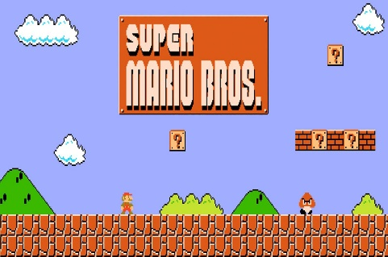

***Figure 1****.* Image of Mario’s in-game sprite and the image of the beginning map of Super Mario

*Source: https://favpng.com/png_view/mario-bros-super-mario-bros-3-new-super-mario-bros-2-png/YxShZ7ar / https://blog.joinknack.com/super-mario-effect*

According to (Hendelmann, 2021), Another modern and controversial platformer game that has been created in the modern era is Flappy Bird. Vietnamese developer Dong Nguyen created it and released it in May 2013 through his gaming firm dotGEARS. You tap the screen to make a pixelated bird fly and avoid obstacles in this smartphone game. By tapping on the screen, the bird can travel automatically to the right while remaining in the air. The game is over if it lands on the ground or one of the pipe obstacles. You will receive a medal for every ten pipes that you successfully clear. Flappy Bird started to gain its popularity in December 2013 by amassing download numbers spiking by 2500% catapulting the game to the top 10 of the free app charts in some countries. On January 17, 2014, Flappy Bird overtook all other free iOS apps in terms of popularity. On January 24th, Nguyen also published an Android version of the game to start off the year. It had been available for Android for a week before it topped the Google Play Store charts.

On February 13, 2014, the developer made the decision to remove Flappy Bird from Google Play and the App Store because of the overwhelming number of interview requests and hateful messages its inventor, Dong Nguyen, got.

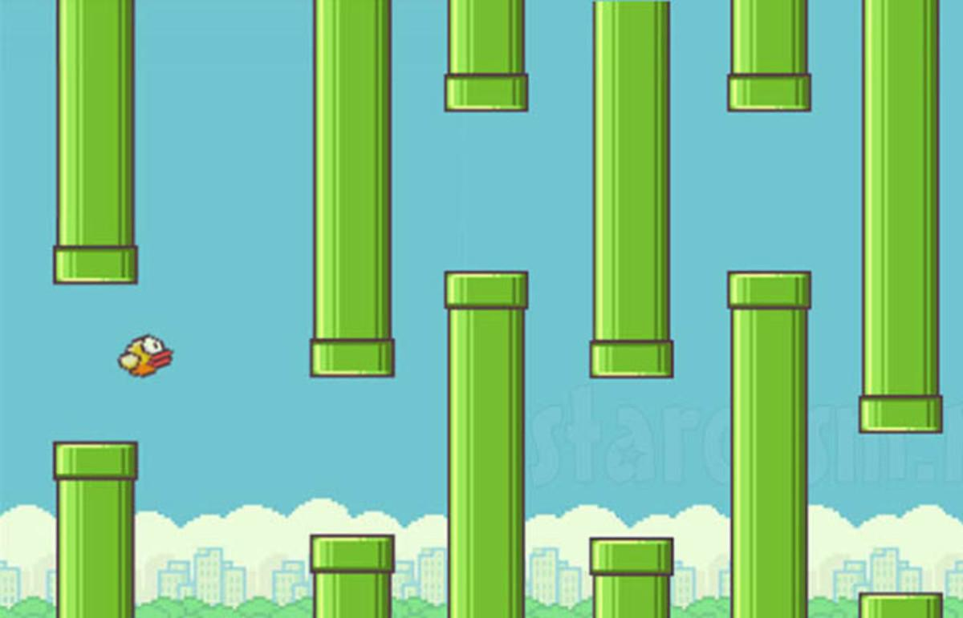

***Figure 2.***Image of Flappy Bird

*Source: https://steemit.com/gaming/@bikalsiwakoti/flappy-bird-mini-game*

***Types of Platformers Games***

A platformer, or platform video game, is one in which players control characters who leap or climb across various platforms on the screen, according to (Klappenbach, 2021). Traditionally, platformers use two-dimensional graphics.

Here are some of the fundamental platform kinds you'll run with either playing or making your own games.

* Standard Platform
  + The foundation of the entire game is the standard platform. Depending on the game you're playing, there are several versions, but the most prevalent one is that characters can only stand on the top and not jump into the bottom. If the character has the power up, the default platform in Super Mario Bros. can occasionally be broken.
* Jump Through Platform
  + The jump-through is the second most frequent platform (and occasionally the most frequent!). Players can jump through the bottom of this platform and stand securely on top because it permits single-direction bypass. Icy Tower, a favorite on iD, and Doodle leap are mostly leap through platform games.
* Slippery / High Resistance Platform
  + The player's difficulty can be changed by adding a material to various platforms. A surface covered in ice is slick, and the character slides across it with no resistance. These platforms may also be covered in metal or oil, or anything else that suggests low friction. On a different material-based platform, the player's character will travel more slowly or have less jumping ability, which is a crucial control in platform games. High grass, molasses, or any other bizarre mixture that may increase friction or stickiness may be to blame for this.
* Sticky Platform
  + Some surfaces are sufficiently sticky that a character can resist gravity. Brighter surfaces enable the character to roll about upside-down or up walls in Sound Shapes, which is an excellent illustration of this.
* Conveyer Belt Platform
  + The purpose of changing platform behavior is to put the player in an engaging and challenging position. The experience is improved by introducing new variables because the player relies on predictable character control. The character is automatically moved in one direction or another, usually toward something dangerous. For years, people have utilized these venues to "throw off" overconfident gamers.

According to Bhosale, T., Kulkarni, S., & Patankar, S. N. (2018), the two categories of 2D games are the top-down camera method and 2D front of the scene camera approach. The player views the visuals from the top down when using a top-down camera technique, which allows for adjustments in all four directions—north, south, east, and west. The entire level is visible to the player. the. The camera is positioned in front of the scene in a 2D front of the scene approach. The arrangement of all game elements to produce a scene is referred to as a scene. In this method, the player only sees the portion of the screen that the camera can record at any one time.

As stated by Minkkinen (2016). Games referred to as "platformers" or "platform games" primarily include a player-controlled figure who runs and leaps to avoid obstacles and/or to kill foes. Platformers are frequently categorized as an action game subgenre and are regarded as one of the original game genres. Platform games have remained popular throughout the years despite being one of the original game genres. Single screen platformers and scrolling platformers are the two main forms of platformers.

Smith et al.’s model for platformer levels is in two parts: components, and a structural representation for how these components fit together. They pay more attention to the internal organization of levels than their visual representation. Platforms, obstacles, movement aids, collectibles, and triggers are the five categories we use to group level elements according to their function.

**Platforms** are any object, such as flat surfaces, loops, or the tops of item boxes, that the player must run across or leap over in order to go through the level.

An **obstacle** is anything that can harm the avatar is considered. Despite the fact that they are not specifically objects in the level, gaps between platforms are also regarded as obstacles.

**Movement aids** are any object that helps the player traverse the level, such as springs, moveable trampolines, or ropes.

**Collectible items** are objects that give the player a reward, such as a coin, power-up, or point reward.

**Triggers** are any object in the level that somehow modifies the state of the level. Switches that convert blocks into money, buttons that activate platforms for the player to sprint across, and items that alter the avatar's behavior are a few examples of triggers.

According to El Habr et al.(2019) 2D platform game that design to be used for conducting research studies on health promotion. It has a basic features of the game and describes how content are procedurally generated. Providing guidelines for suture studies with two illustrative examples.

There are 6 level design patterns according to Khalifa et al. (2019): Guidance, Foreshadowing, Safe Zone, Layering, Branching and Pace Breaking. Although the patterns are shown separately, they can be merged or altered to deliver a unique and novel experience. New design patterns may frequently be created from combining or altering already existent patterns. These patterns are not prerequisites for producing a high-quality game; rather, they are standards that might enhance player experience. The formalization of these patterns helps generate a common vocabulary for developers, fostering the growth of knowledge. Although each pattern is discussed separately in this book, pairing them together is frequently done.

## Difficulties of History teacher in teaching History

The first difficulty is the general one of introducing young minds into historical study; the second, the limitations of historical material and the teacher, and third, the previous work in history.

## *Video Games as Medium of Teaching*

Brenner-Adams et al. (2017) state that Game based learning or GBL have been known to enhance the learning processes in a number of areas such as critical thinking, problem solving, systems thinking, creativity, and development of identity. It is the notion of imparting knowledge via game-based learning. The main goal of GBL is to provide players with the skills and/or information needed to execute a task outside of the video game in which they are playing.

Boom et al(2020) states that Video games that include historical themes, settings, or narrative elements offer great experiential learning opportunities. Their naturally interactive nature enables an immersive experience, which leads to a deeper and more comprehensive comprehension of the past being portrayed.

According to Choi et al.(2020), video games are suggested to enhance cognitive functions. It is discovered that different video game genres are associated to a variety of cognitive functions such as attention, probabilistic learning, problem solving skills, visuo-spatial function, and working memory. Examples were that frequent video game players of different genres were better at sustaining attention. FPS gamers were discovered to effectively allocate attention through the top-down process of attention.

Zirawaga (2017) states that due to the nature of history as a subject, it is essential to offer more recent and budding technologies to assist the primary method of instruction. In contrast to courses like mathematics and science that appear to be more vital, history deals with facts that need to be recalled exactly as they are. Students may not feel the need to learn to understand terminology and concepts but may feel the need to learn merely so they may do well on the exam and forget about the course if History is seen as a topic of little value in the world. It is becoming clearer that engaging students in such a course is necessary to ensure that they retain the material even for future use. With that in mind, students will be able to see the course differently if game theories are used since history gives more than a summary of the past.

Tian(2020) state that more positive comments were generated by the complementing visual effects for the core gameplay. When visual effects and game mechanics are merged, more immersive play experiences are likely to be created. Since the visual effects in the game did increase play testers' knowledge of the game, they came to the conclusion that blending visual effects with game mechanics is an advantageous design idea. On the other hand, using visual effects for optional game features or solely for decoration should be avoided unless the designers want to transmit a certain mood to players.

According to Cam et al.(2017), students are more eager and motivated to join games than they are with a variety of exercises. The authors claim that when students study using appropriate games, they not only increase their knowledge but also apply it to their education. Furthermore, Ersoz (2000) shows how highly motivating challenging and entertaining games are. Students were ecstatic when teachers announced that it was time for games. In fact, teachers can utilize games to foster camaraderie among students in the classroom or to motivate and entertain kids via competition.

According to Nand (2019), gamification can be used in education at all levels, including primary, higher education, and lifetime learning. In a practitioner’s guide to gamification of education (Huang and Soman, 2013), the authors provide a five step process:

1) Understanding the target audience and the context

2) Defining the learning objectives

3) Studying the experience

4) Identifying the resources

5) Applying gamification elements.

During gamification, some key criteria to be considered are the duration of the learning program, the location of the learning, the nature of the learning programme, and size of class. Olsson et al. (2015) pointed out that in a virtual learning environment users usually feel lonely and puzzled in their learning journey, therefore visualization and gamification may be applied as solutions, but the former worked better than the latter.History

According to Harris, C.A, Mong, C.J, & Watson, W.R., (2011), using a videogame to teach a student can't ensure learning or engagement on its own; the teacher must be involved as well. For example, the teacher must understand how the game functions, present the learning objectives in advance, find a game that is appropriate for the curriculum, have the school administration's support to purchase the game, have the game's hardware implemented, and justify its use, as well as understand the primary reason why a videogame is used.

For hundreds of years, games have provided entertainment; and will do so in the future (Sailer, Hense, Mayr, & Mandl, 2017). The principles of gamification can be used to maximize the potential of games. Gamification's primary goal is to boost engagement (Kapp, 2012, Villagrasa et al., 2014). The two biggest problems teachers in schools confront are low student engagement and a lack of motivation (Lee & Hammer, 2011). The deliberate use of games to achieve educational goals is another facet of gamification. Game-based learning (GBL) is the use of video games in educational settings to further learning objectives (Wiggins, 2016). Student engagement has been observed to increase with game-based learning (Wiggins, 2016). Serious games (SGs), a type of game-based learning, have been used to teach subjects like biology, computer science, commerce, and science.

Gamification, which is regarded as a "growing trend," entails maximizing and utilizing game principles and aspects in non-game contexts as opposed to only building a basic game solely to cater to entertainment demands. It takes a lot of work to mix entertaining elements with the non-game target, but the goal is to increase the user's motivation and engagement. The idea behind this activity is that the joy and entertainment value of video games should be transferred to other non-game apps (Flatla, Gutwin, Nacke, Bateman, & Mandryk, 2011). Gamification is thought to have the potential to amplify the user experience with game elements while also absorbing

By including game aspects like points, levels, badges, and leaderboards, gamification aids teaching and learning in an intriguing and enjoyable way. A well-designed gamified lesson provides learners with a pleasant experience that is reinforced with educational opportunities and unprompted feedback that enables them to gradually increase their knowledge (Bouchrika et al., 2019). Gamification, which has been shown to increase and improve students' engagement, motivation, social impact, and academic success, is believed to improve the entire learning process (Zainuddin et al., 2020). The success of the teaching-learning process depends on motivation, which is directly related to learning (Gopalan et al., 2017). It piques students' interest in the subject matter and motivates them to actively engage in learning activities, both of which lead to an increase in their desire to learn. According to studies by Huebner Gilman et al. (2009), Martirosyan et al. (2014), and others, students who reported having pleasant school experiences and being content with their learning experiences also had better levels of academic accomplishment and general life satisfaction (Suldo et al., 2014).

A group of technologies supporting extremely engaging, frequently two-dimensional, interactive virtual worlds with few variables is what is referred to as an educational simulation (Lamb et. al., p.160). These simulations, which let the player manipulate and experiment with the environment on the screen, are designed to appear as authentic as possible. The goal of creating education simulators is for individuals to learn in a realistic environment; it is not just for amusement. Digital educational games in particular offer a new way to learn by playing and experimenting with various ideas and concepts in order to learn properly.

Games can be utilized as a teaching tool in addition to being a source of amusement. Particularly in learning complex or overly theoretical material, appealing learning tools can improve the interest of young people or members of the millennial generation. Games can boost student engagement when they are made with learning principles in mind. Learning, engagement, and inspiration. Game-based learning encompasses more than just making games for students to play. Creating learning activities can gradually present the ideas and direct users toward the desired outcome. According to Hamari Research, instructional video games can successfully engage students in the learning process and can be triggered by stepping up the difficulty and inventiveness requirements while playing the game. For game-based learning, there are 11 essential game design elements, including game goals, game mechanisms, game fantasy, and game value, interaction, liberty, story, sensation, difficulties, sociality, and mystique.

Digital games have dominated the world and ingrained themselves in our social and cultural landscape as a result of the rapid growth of technology and life's digitalization. Digital games offer interesting experiences, interactive learning environments, and cooperative learning activities; as a result, their popularity has exploded in recent years. Digital games are today seen by industries, businesses, governmental agencies, and academic groups as a potent social, technological, and cultural force that cannot be disregarded. The learning of academic subjects might become more student-centered, absorbing, fun, and interesting through the use of games that are designed to contain educational objectives and subject matter. This would increase learning effectiveness and efficiency. Games are "an engaging, voluntary, and entertaining activity in which a demanding goal is pursued according to agreed-upon rules," according to Kinzie and Joseph (2008).

Although there is increasing evidence that GBLEs can be an effective learning tool during the past decade, there is a complicated relationship between game design and student learning (Clark et al., 2016; Mayer, 2014; Wouters et al., 2013). The student may nevertheless believe they have a high level of student agency if a GBLE is constructed in a way that gives them the impression they can execute some action in the virtual environment, such using a virtual object, even if they are unable to do so in reality. Increased student agency is correlated with higher levels of involvement and better learning outcomes in GBLEs, according to studies, albeit the relationship is not always clear-cut (Sawyer et al., 2017; Rowe, Shores, Mott, & Lester, 2011; Snow, Allen, Jacovina, & McNamara, 2015). When introducing game features that offer more degrees of freedom and control, such as letting students explore an open world area, it's crucial to make sure that these mechanics also support the activity's main learning objectives.

Due to the sudden changes in education brought on by COVID-19, higher education significant difficulties in properly implementing educational solutions (Sutton & Jorge, 2020; Toquero, 2020; Strielkowski, 2020) will pursue further study via distance learning (Bozkurt, 2019) despite COVID-19's spread. The use of computers, cellphones, and other technology to enhance learning and teaching. Every school needs to adopt the method in order to be relevant in the modern world (Barrera, Jaminal, and Arcilla Jr., 2020). According to studies, using games to teach students could enhance their learning outcomes ( Brezovsky, 2019; Wardoyo, DwiSatrio, and Ma'rufm 2020). Certain benefits came with digital games. Fundamental principles of memory-based cognitive learning (Wu et al., 2020). Particularly, pupils with an increased inner motivation levels and a positive outlook on GBL are more likely to result in higher To achieve learning goals and feel more satisfaction from their GBL involvement (Vlachopoulos and Makri, 2017), which suggests increased motivation for learning students (Auman, 2011).

The utilization of games as an educational tool can definitely aid to improve learning and growth. Contextual learning tool for classroom training. Professional development should explain how social learning theory and game-based learning relate in the classroom (Polin, 2018). Educational games have been defined as apps that integrate aspects from video-related mobile games to build engaging, immersive learning experiences with predetermined objectives. Developing these types of games propose obstacles, encourage various degrees of participation, offer enjoyable multimedia, and prompt comments (Denden, Essalmi & Tlili, 2017). Digital games have strong educational potential, to the extent that education has transformed society.

Based on Chang W (2009) study, students can benefit from effective learning activities and engaging learning content with problem-solving strategies by implementing Virtual Game-Based Learning, or V-GBL, learning resources. This learning system's utility rate and learners' learning ability both have room for improvement. Since the V-GBL environment attempts to incorporate a variety of gaming subsystems to enhance the interaction models throughout the learning activities

Hooshyar (2021) remarks that their results show that an adaptive game may be more effective at improving students' learning attitudes than a traditional method in terms of the impact of various learning approaches on students with various prior learning attitudes. More specifically, compared to the traditional method, the adaptive game could more effectively improve students' prior learning attitudes in comparison to those with lower prior learning attitudes, while both the experimental and control groups' students with lower prior learning attitudes also demonstrated similar gains in learning attitude.

In order to understand teacher and student experiences, this study employed a qualitative case study approach (Stake, 1994). Patton(2002) defined cases as a “specific, unique, bounded system.[in which researchers] gather comprehensive, systematic, and in-depth information” (p. 447). In this study, the research team focused on the high school history class as our specific unit of interest. The research was conducted by a team of two graduate students and one professor with backgrounds in educational technology. The graduate students had varying professional backgrounds with experience in corporate, K-12, and higher education settings. Methods were guided by constructivist grounded theory (Charmaz, 2000) where research methods are analyzed during the study by the researchers and emergent questions are identified to direct and revise the research approaches to better fit the context of the studied phenomenon.

As previously discussed, data was collected from focus group interviews with students, from an interview with Mr. Irvine, the teacher, and from collected assignments, field notes and video recordings of the classes. The two larger themes which arose from analysis of the data are student engagement, and teaching strategies and classroom integration. The consistency of the participation and engagement of students are evident throughout all of the student focus groups.

According to Mr. Irvine, he integrated the game into his classroom through these several key factors.

1. Teachable moments and focus on learning,

2. goal orientation, reflection, and position taking

3. learning to play the game

As a case study, this study has limitations in how well its results generalize to other situations. However, these results can still be used to inform the implementation of video games in classroom environments. Certainly further research is needed to better identify the best practices in using video games in the classroom.

Before making the game, a literature study was conducted to find out which gamification model is suitable to learn history. The second step is to decide which historical lesson will be covered in the game. The story of General Sudirman was chosen because there are not many papers that cover this lesson. Also, Sudirman was the first general of the Indonesian National Army to fight invaders using guerrilla tactics during the Second Dutch Military Aggression. The third step is to design the game script which covers the history of Sudirman by gathering information from biography books about Sudirman. The game elements and terminologies are listed below.

|  |  |
| --- | --- |
| **Game Element** | **Brief Description** |
| Missions/quests | The game will give missions to the player displayed on the top right of the screen to advance through the story. The missions vary from find items, defeat enemies, or meet a certain character. |
| Scores | Reflects how well the player answers all quizzes. The score will be displayed at the end of the game and stored in the leaderboard. |
| Map | The player could move around the map to explore the region of Sudirman’s location. The map was made according to the location of Sudirman’s route while in the war against Dutch  soldiers in the past. |
| Mini-games | There are mini-games in the form of quizzes for each chapter about Sudirman or events around him. Failing to answer the quiz will make the player repeat the last chapter of the game. |
| Background Story | The game will narrate Sudirman's early life along with the events that make Sudirman become  a General of the Indonesian Army. |
| Characters | Historical characters that had some interactions with Sudirman, either Indonesian government officials, troops that fought alongside Sudirman, or Dutch officers. |
| Enemies | At some point, the player must fight the Dutch army to progress further. Enemies could also be the requirement to clear a mission. |
| Items | Items could help players to progress or win battles. Items could also be the requirement to clear a mission |
| Leaderboard | Displays the top 12 highest scores the player has achieved after the game ends |

*Table 1.* Game Elements of the study of (Kusuma, et al, 2021)

The game is developed using RPG Pro Maker MV and programmed using JavaScript After finishing the game and testing it, the game is deployed to be installed on Android phones The next step is evaluation of the game-based learning through a quasi-experimental. This study also proposes a research framework to measure the effect of the proposed learning model in improving students’ learning motivation and achievement.

The experiment was conducted by involving 63 participants, with the proportion of 34 university students and 297th grade junior high school students. Each participant was randomly assigned to use one of the learning media either game or web. After the random assignment process, 32 participants used the game and 31 participants used the web. Before conducting the necessary tests to prove the hypothesis, we conducted a validity and reliability test using Cronbach’s Alpha to determine whether data gathered are useful. As mentioned before, there are 63 participants in this test. The result’s Cronbach’s Alpha is 0.938 which means the data is very reliable. Despite that, the results for questions number 22, 26, and 31 are invalid as the Cronbach’s Alpha for #22 = 0.174, #26 = 0.760, and #31 = 0.440.

Shapiro-Wilk is used for the normality test; the data are not normally distributed because some of their Shapiro-Wilk scores (Sig.) were higher than 0.05. This requires the researchers to use the non-parametric test to evaluate their hypotheses.

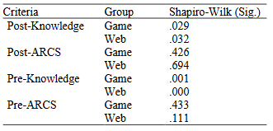

*Table 2.* Normality Test Result

To analyze all data, we use Ranked Analysis of Covariance (ANCOVA) to test hypotheses set 1 and 2.

Sharritt (2008) remarks that games have the power to change how learning is perceived by children, turning it from a chore to something fun. Teachers and game designers must have a thorough understanding of the real learning process in order to be prepared.

Carriazo (2007) emphasizes the widely held belief that interactivity is a key component of media-based learning. Despite the fact that their findings do not support this belief, it is clear from their research that conducting a lesson through a game is much more effective than learning on a text-book basis because learning through a game is more enjoyable than learning in a traditional way, such as by reading textbooks.

Hooshyar (2021) remarks that their results show that an adaptive game may be more effective at improving students' learning attitudes than a traditional method in terms of the impact of various learning approaches on students with various prior learning attitudes. More specifically, compared to the traditional method, the adaptive game could more effectively improve students' prior learning attitudes in comparison to those with lower prior learning attitudes, while both the experimental and control groups' students with lower prior learning attitudes also demonstrated similar gains in learning attitude.

Based on Bourgonjon (2013) data, the data given indicates several significant problems that influence instructors' acceptance of games as teaching aids. The most essential thing to note is that instructors' perceptions of how relevant video games are to their instructional practices appear to be a key driver of change. Therefore, it may be claimed that a model intended to characterize and predict the uptake of commercial games by secondary school instructors should take into account both utility and learning opportunities. Although its relationship to the other aspects is still unclear, such a model should also answer instructors' worries about the difficulty of employing games in the classroom.

**Using games/entertainment as a way to teach History**

Gede Putra Kusuma (2021) states that the motivation and achievement of pupils in their study of history can be greatly increased by employing gamification. Despite this, only a few missions, quizzes, and cutscenes are used to cover the study's learning elements. When compared to learning materials, the roleplaying game's gameplay core still predominates. Learning materials include grinding for experience points so that the characters' status could be improved, completing transactions at the shop, engaging in combat, and unlocking skills as you play. Players may become solely focused on winning the game rather than comprehending the lectured information as a result of those factors. The offline game was also a subject of this study, which some players can find tedious after a time.According to Admiraal, pupils were more interested when given assignments that required competition and activity as opposed to simply walking around the entire city and learning things that way.

According to Ardito, games can be a useful tool for teaching history and understanding it. He said that a game must be enjoyable for the students to be able to retain the information because enjoying something tends to make it memorable. He then added that playing games typically requires several different skills at once, which can help one improve their skill. Finally, he said that a game should encourage relational activity that fosters group interaction, encourages collaboration, and aids in conflict resolution.

According to Manas, strategy games are excellent teaching aids for history because of their many benefits. The key concept behind these games is not the realism of the graphics they display, but rather the game rules that control how far a player can advance in the game and support the previously mentioned learning process.

Barr (2018) says it's crucial to make the game fun for the students so they will fully interact with it because, when it comes to educational games, kids tend to know they are playing for learning and not enjoyment, which typically prevents them from truly engaging with the learning.

According to Admiraal (2011), digital games, whether or not they use location-aware technology and mobile devices, have the potential to revolutionize education and challenge the generally held belief that games are nothing more than "mere entertainment." The majority of young people today have completely different attitudes toward education than they do toward their video and computer games. On the other hand, that is precisely the mindset we want all of our students to have: one that is interested, competitive, cooperative, results-oriented, and actively seeking knowledge and answers. Therefore, it makes a lot of sense to attempt and combine the educational material with the fun and inspiring qualities of games. A motivated student demonstrates a strong interest in and enjoyment for what they are doing,

Based on Waninger, others believe that traditional education should be able to adapt to technology and maximize the way gamers think, but aside from this, the educator themselves should be aware of whether using video games to teach their students would be the most effective method and whether they would fit into their curricula.

Ritterfeld (2005) implied that the enjoyable nature of game play offers sufficient internal incentive for persistence and, ultimately, learning. By allowing for implicit or explicit educational goals, purposeful and/or incidental learning—which may include complicated problem solving—can be facilitated. Additionally, including a reward system implies that learning must be intentional and that the educational aim must be clear. As was already mentioned, playing games for reinforcement can help with practice but cannot help someone overcome problems.

According to Squire, simulations' instructional value is often found in the total simulation experience rather than in the program itself. The generation of the kinds of understandings that educators might want is not guaranteed by simply deploying a simulation. Instead, instructors should provide students the chance to reflect and debrief, and the amount of time spent doing so should be equal to the time spent playing games or participating in simulations. By encouraging collaboration, encouraging reflection, and organizing extension activities, instructors play a significant part in this process.

Young states that the keys to learning and "fun" are the capacity for accommodating a range of player abilities from novices to limitless expert potentials in a variety of areas, the accommodation of player abilities from novices to unlimited expert potentials in a variety of areas, the ability to detect progress or success in a competitive sense, the experience of new and unusual circumstances beyond everyday activities, the capacity for forming social alliances and performing feats beyond the capabilities of any one player alone, and the accommodation of player abilities from novices to unlimited expert

# Unity as the platform used for Game Development

According to (Dave A., 2022), there 11 key benefits for using Unity in Game Development. Those 11 key benefits are the following.

|  |  |
| --- | --- |
| Key Benefits | **Description** |
| 1. User Friendliness | Unity is more convenient to use as compared to other technologies. Other tricky technologies become more complex while used. |
| 2. Compatibility with Several Platforms | Unity has compatibility with multiple Operating Systems, such as Steam, iOS, PCs, Macs, Android, and consoles. Hence, using Unity, you can quickly build many games for different platforms and design multiple game stages. |
| 3. Online Tutorials | The most convenient fact about Unity is that many training videos and tutorials are available online for every learner. You can even develop easy and small games with training using Unity. |
| 4. Availability of the Rich Asset Store | The Unity Asset Store provides game developers with a wide range of textures, pre-designed 3D models, unique animations, sounds, scripting languages, and object modeling, like a scenic backdrop, a popular character, a building, etc. |
| 5. Multiplayer Gaming | Some of the most popular multiplayer games are made on the Unity engine. The platform offers many features that encourage developers to build high-end games for online players. |
| 6. 2D Game Development | Although Unity is primarily used for 3D game development, it includes features to create 2D games as well. The latest Unity version features the in-built 2D engine and rich assets to help developers build 2D games most conveniently. |
| 7. Community Assistance | Unity provides uninterrupted assistance from the team of developers. More than 2.5 million developers currently use Unity programming, and the number of users is increasing fast. |
| 8. Access to both Free and Pro Version | Unity is available in both free and pro versions with numerous features. You can select the free version and receive the highlights of the primary elements. |
| 9. Top-Notch Graphics | Unity is famous for its next-level, top-notch graphics. The game engine provides highly customizable rendering technology and different engaging tools to aid superb-looking game development. |
| 10. Less Coding | Unity is feasible for beginners who want to start game development as a hobby or career. It uses Boo, JavaScript, and C#, but you can build a game without code writing. |
| 11. Debugging | You can see every game variable during gameplay |

*Table 3. Key Benefits and Description*

**Design and Implementation Visual Environment of 2D Puzzle PlatformerComputer Game: ASCENDER**

In this literature, the researchers developed a game called ASCENDER which is a single player 2D puzzle-platformer-PC game built with Unity game development engine.The environment set of Ascender game has an explorative set in a great cave under the land surface, which Indonesian called ‘Goa’. The main playable character named Sky, a bipedal dog-sized robot assistance set on adventure helping its owner, the teen limbless girl named Ocean and Professor Toro Hudo in their mission to collect materials that will be useful to create artificial arms and legs for Ocean.

On creation of their storyboard, First step was to make focus ground based on the design curve level plan, provided by game designer.The game designer was using a drawing of basic elements as simple as possible so the artist could understand and build the set environment corresponding.

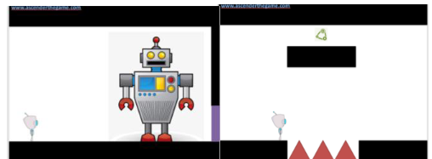

*Figure 3: Simple Level Design Drawing by Game*

*Designer*

*source: https://www.jstage.jst.go.jp/article/adada/21/1/21_73/_pdf*

In the Figure X above, the picture on the left for example,the main robot character is the little one on the left, and the big robot as a non-playable character (NPC) is on the right. The Interaction between the main character and the NPC can trigger a quest. This scene is located at the big workshop in a warehouse called AIR where all the Artificial Intelligence Robots get their operational license after they complete the tasks. The Warehouse is quite big and packed with rusty hightech materials. To visualize this scene, an environment artist created a storyboard that focuses the main ground (focusground).Storyboard is the most important tool in visualizing reproduction on any project, including game. Making the game storyboard not only helps the visual artist to organize and improve game assets, but also enable the entire game production team to organize and improve all the elements of the game design.Game storyboard was drawn scene by scene with pencil on A4 size paper sheet. This A4 size represents one block map area which game designers use in Microsoft Office Excel Format to determine the length total area for every district andwhere they connected to each other. The length of every district varies depending on the concept.In Excel format map, each district was separated by different color, see Figure XX. Visual artist then connected those storyboards in A4 paper according to excel maps and posted them on the wall, so the visual flow in the storyboard can be seen and optimized. The storyboard is also coated with separate transparent paper for drawing action and quest planning by game designers.

*Figure 4: Microsoft Excel Map Format*

*source: https://www.jstage.jst.go.jp/article/adada/21/1/21_73/_pdf*

After all storyboards have been approved by the art director, the next process is coloring the main ground using a color palette which has already been decided on the concept art. The main ground (focus ground) coloring process was done in digital coloring using Adobe Photoshop with resolution set at 1600 x 900 dpi.After cleaning the storyboard, artists made grayscale blocking to determine which part is dark and light before the coloring process began. Based on that grayscale mapping the artist can start coloring.

*Figure 5: Coloring Process of the Game’s Setting*

*source: https://www.jstage.jst.go.jp/article/adada/21/1/21_73/_pdf*

Figure 5 shows the coloring phase on the main ground inEverest District. Everest is the holy district located in the coldzone, where the environment is mostly dominated by giant tree roots. In consequence, the color corresponding in that area was dominated by cold color. In addition, to accommodate magical and spiritual feel in the said district, the main color used wascool pallets as purple, reddish brown, and a slight blue and green as complementary colors. The tension of color relationships.

A complete coloring process also gives detail about the environment condition and identification on each material such as steel rust, grass, plantation, ice, lava, etc. By applying

different color tones and schemes on each district correspond to each district feature characteristic of Goa, it could give a different personality and enhance game visual experience. For Example, the Mustang District that is mainly used for farming area, the most fertile district in Goa most suitable for growing plantation for food source is colored with brown and greenish color scheme. A complete coloring process not only detailed done on the main ground, but also on background, foreground,and each parallel layer with different depth in game that called

parallax scrolling.

*Figure 6: Helion District Final Layout*

*source: https://www.jstage.jst.go.jp/article/adada/21/1/21_73/_pdf*

Compositing all the environment element was done with the help of programmer as visual implementation in game whereall assets were stitched together in every layer to make a

beautiful environment with parallax scrolling. Some minor fixes and adjustments were needed from the artist in order to patch the hole in visual parallax or just to make the visual environment seamless in every district in Goa. The exampleresult is the environment layout on Helion District as shown in Figure 6 above.

**The Development Process of Awang Sains 2D Digital Mobile Game**

This article presents the process of the development of a 2D digital mobile game; Awang Sains. The Game has been developed based on features that have been identified, and will be tested for its heuristics – usability, mobility, playability, learning content, local content, language and aesthetics.Fifteen experts were selected to play and then test and evaluate the game. The objective of this game is to use it in teaching and learning Science year 4. The study used design and development research (DDR)embedded with the ADDIE model (analysis, design, develop, implement, and evaluate), based on pedagogy and the instructional need to make the software meaningful with the ability to help pupils master Science subjects.In designing the game, the most important is the character that attracts pupils to the game. Hence, we

created the character and named him ‘Awang’. This character is designed with Malay looks and is wearing “baju Melayu and songkok”. Shown in Figure XXXXX.

*Figure 7: Character Sprite of Awang*

*source: https://www.jstage.jst.go.jp/article/adada/21/1/21_73/_pdf*

This level involves the development of a real game by inserting all the elements of media and technology that have been chosen based on the study. Development is a process for developing software or digital games, such as storyboarding, graphics design, and programming (Nisa, 2004).When this phase is developed, the necessary teaching and media steps will be used in teaching and will also look at the documents (Umar, Abdul Rahman, Mokhtar, & Alias, 2011).

The development of this game software should conform to the developmental characteristics of a teaching aid that links excitement and learning. As stated by Kassim, Nicholas, and Ng (2014),multimedia-based learning must be designed and developed according to the learning needs. Digital Video games that meet the fun and learning features must have mechanical elements, such as visuals,narratives, incentives, appropriate music, and clear academic content and skills (Plass et al., 2015).This game has been developed using a video game engine that is available on the market. Such game engines include game maker, Unity 2D, Click2fusion, and touch develop. In this instance, the researcher chose the Unity 2D game engine and certain software, i.e., Adobe Photoshop CC 2018,Microsoft Paint, Autodesk SketchBook, and GNU Image Manipulation Program.

The development of this game software should conform to the developmental characteristics of a teaching aid that links excitement and learning. As stated by Kassim, Nicholas, and Ng (2014), multimedia-based learning must be designed and developed according to the learning needs. Digital video games that meet the fun and learning features must have mechanical elements, such as visuals, narratives, incentives, appropriate music, and clear academic content and skills (Plass et al., 2015). This game has been developed using a video game engine that is available on the market. Such game engines include game maker, Unity 2D, Click2fusion, and touch develop. In this instance, the researcher chose the Unity 2D game engine and certain software, i.e., Adobe Photoshop CC 2018, Microsoft Paint, Autodesk SketchBook, and GNU Image Manipulation Program.

**Pathfinding Algorithms in Game Development**

According to the researchers, The rising global popularity of video games was the trigger to the increasing research interest in solving many AI issues related to video games such as decision-making, movement, strategy, and pathfinding.Commonly, pathfinding for a non-player character uses up a lot of CPU power and memory. This is a problem that has attracted constant attention from researchers.

Pathfinding is a plotting node to find the shortest or minimum path between two points, which is from source to destination by a computer application. Pathfinding is a major component of many important applications in the fields of video games, robotics , crowd simulation , and GPS . This paper focuses on pathfinding algorithms in video game development. Pathfinding algorithms are used for the agent or non-player character to find a path between the origin point to the goal point. Pathfinding is one of the requirements to create a realistic non-player character in a video game. A video game can be fun and entertaining especially when the non-player character is realistic enough. However, the main problem for a video game is the need for an optimal pathfinding for non-player characters. Garham has supported this by stating that the common problem in a video game is to find suitable pathfinding foragent movement. Pathfinding is implemented in any condition such as static, dynamic and real-time environments. The techniques or methods used to determine the path in a video game are called pathfinding algorithms. Pathfinding algorithms were developed to solve pathfinding problems such as Dijkstra, A* algorithm, genetic algorithms, and ant colony optimization. Pathfinding algorithms are used to solve the shortest path problem and the optimal path.

The relevance of this paper comes with the utilization of A* Pathfinding Algorithm.The A* algorithm is one of the popular techniques used for pathfinding due to its accuracy and performance. It is used to find the shortest path between two nodes. The A* algorithm has been applied in several video game genres such as real-time strategy games, role-playing games , racing games and turn-based strategy games. The A* algorithm was introduced by Hart, Nilsson, andRaphael in 1967 [12] to solve many problems, pathfinding in a video game being one of them. In theNon-Player (NPC) context, pathfinding is used to guide between two node points in order to capture the player character.

*Figure 8: A* Algorithm*

*source: https://iopscience.iop.org/article/10.1088/1757-899X/769/1/012021/pdf?fbclid=IwAR22k9w2sl1gTICSV4i12J6az4BhgiuFCSreyo57qU8GxEtHqFnn9y1-_Mk*

The A* algorithm always tries to carry pathfinding by exploring the minimum value or lowest path to give the best minimum solution. The A* algorithm implements a heuristic function to evaluate that lowest path. The heuristic function allows the algorithm to quickly and accurately estimate the path. The Advantage of the A* algorithm is very easy to understand the flow and logic. Due to its simplicity,the A* algorithm has always been chosen by programmers to solve pathfinding problems. This is because the A* algorithm finds the minimum solution by finding the shortest path. A* uses a heuristic function 𝑓(𝑛) to determine the node. The value of the function 𝑓(𝑛) is:

𝑓(𝑛) = 𝑔(𝑛) + ℎ(𝑛)

*Equation X: Function $f(n)$*

𝑔(𝑛) is the cost that is required to reach a target node from the starting node. 𝑔(𝑛) will calculate the cost sofar to reach the target node. ℎ(𝑛)stands for heuristic value, where estimate form node to target node. If thegrid has obstacles, 𝑓(𝑛) will estimate and pick the lowest cost to give a good result. The A* algorithm becomes Dijkstra’s algorithm when ℎ(𝑛) is zero which is guaranteed to find the shortest path.

**Side-Scrollers** refers to 2-dimensional games where the characters or objects progress sideways, generally seen through a side-view camera angle, thus, the term “side”-scrollers. Some examples of famous side-scrollers are metal slug, super mario bros., and castlevania.

**Game mechanics** refers to the set of rules in which the game is played. This includes player movement like jump height, sprinting speed, and gravity. This can also include object interactions such as collision type, collision model, friction, and more.

**Assets** are premade objects that can be used to create prefabs in the developer. These are simple objects like texture, shapes, animations, and more.

**Prefabs** are objects made in the developer that will be used over and over again as a preset. Prefabs are used to avoid repetition of work and to standardize the design and mechanics of the objects in the game. For example, a rock, platform, box, enemy model, etc.

**Skyblock** refers to the outermost background of the visuals in the game. Skyblocks are most of the time, picture of the sky, space, indoor venue, cave, and more.

**Mobs/NPC’s (Non-Playable Characters)** are characters in the game aside from the one that the user controls. Mobs are usually background characters that the player interacts with in the game to progress the story.

**Conceptual Model of the Study**

Based on the information gathered from related studies and literature, a conceptual model was formed, as illustrated in Figure X.

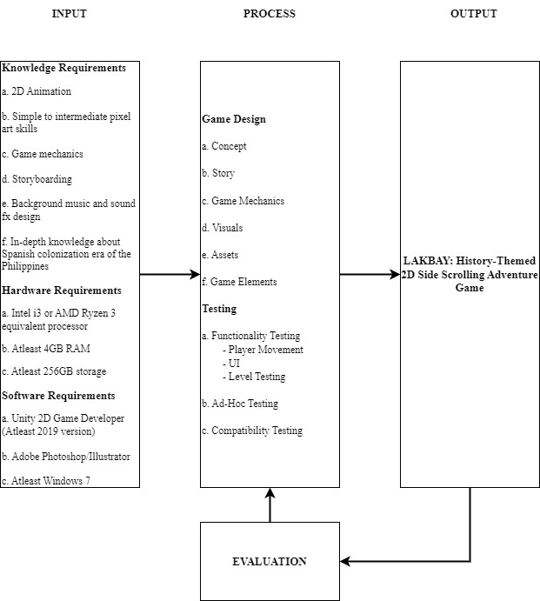

***Figure 9.*** *Conceptual Model of the Study*

**Input**

The input section consists of three requirements: Knowledge, Hardware, and Software Requirements. Knowledge requirements features basic C# and Unity programming, basic pixel art skills, knowledge about game mechanics specifically on 2D side scrollers, storyboarding, and lastly, knowledge about the Philippine history from the Spanish occupation. Hardware requirements on the other hand consists of only two things, a capable laptop or desktop and a proper internet connection. Lastly, software requirements consist of Unity Game Developer for making the game, Adobe Photoshop or Illustrator for editing the visuals, and at least Windows 7 OS needed for both programs to run.

**Process**

The process section defines the stages of system development for the study. First part of the process is Game Design, which is divided in five parts, namely: Concept, Story, Game Mechanics, Visuals, Assets, and Game Elements. Which then leads to the Testing procedure, which features three phases: Functionality Testing, Ad-Hoc Testing, and Compatibility Testing. All of the processes are discussed further in the Chapter III Methodology.

**Output**

With the input and process stated above, the output of the model is “LAKBAY: 2D Adventure Side Scrolling Game”, which is put through evaluation involving volunteer respondents. The game is be evaluated based on its functions, playability, and general performance.

**Operational Definition of Terms**

The following terms are defined operationally to better understand the system and the game.

**Obstacles** are intentionally placed game terrain that makes it harder for the player to continue forward. Obstacles are usually placed strategically to push the limits of the player movement, sometimes requiring power-ups to complete.

**Power-ups** are items that gives a temporary competitive advantage or new skills to the player. It is used to help defeat enemies or get across a difficult obstacle that usually cannot be completed without such boosts.

**Projectiles** refers to the damaging objects the enemies shoot out. Projectiles are meant to harm the player and is to be avoided, but there is a power-up in the game that allows the player to shoot, damaging enemies instead.

**Objective** is an item or destination that is needed to retrieve, reach, protect, or destroy in order to accomplish the mission. Objectives differ from stage to stage, and there can be multiple objectives in a single level.

**Interactable Objects** are objects that the player is meant to interact with. Examples include opening a chest, acquiring a key to open the door, destroying a crate or a vase, and more.

# Chapter 3

# METHODOLOGY

This chapter presents the project design, project development, operation and testing procedures and evaluation procedure. This section of the study demonstrates how the application was designed and developed, as well as how the researchers executed and tested the program.

**Project Design**

This section discusses the system functionality, game design, and how the game was made. As said in the objectives of the study, the game was made using Unity Game Development which generally uses C# programming for the back-end. The back-end is generally used to tweak game mechanics such as player movement, collision, object interaction, customization of assets, and overall functionalities. The front-end on the other hand includes level design, text/speech prompts, customization of menu, and addition of sound effects and background music.

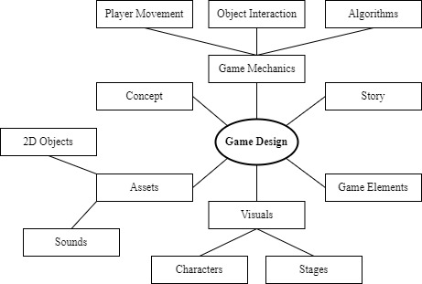

***Figure 10.***Game Design

**Concept**

**A. Type of Gameplay** – There are many types of 2D game genres. Specifically, LAKBAY is a side-scrolling platformer. The game is played solely in a side-view camera angle, in which the player can move left, right, up, and down. The camera follows the character in the frame as it progresses through the map.

**B. Objective** – The objective of the game, generally is to move the player from point A to point B, point A being the starting spot where the mission is given, and point B being the end point where the mission is completed. Specifically, LAKBAY gives users specific missions (Ex. finding an object/character, defeating specific boss, maneuvering through an obstacle, etc.) to accomplish in order to progress the story while avoiding or destroying enemies in the way, and searching the end point to move on to the next chapter.

**Story** **and Game Elements**

The story of the game features five chapters/levels, each with its own different stories and missions to accomplish. The player must complete the preceding level before continuing to the next one, otherwise, the level will not be unlocked.

**Setting** – The main setting of the story is the 18th-19th century era of the Philippines where the Spaniards colonized the country. Each chapter of the story features different significant places and events that existed in real-life (Ex. Battle of Tirad Pass, Declaration of Freedom in Kawit, etc).

|  |  |  |  |
| --- | --- | --- | --- |
| **Stage 1:** Ferdinand Magellan’s Voyage | | | |
| **Location:** Ferdinand Magellan’s Ship (Trinidad) | **Description:** Year 1519, F. Magellan was on his way to the Philippines unknowingly thinking it was Spice Island. | | |
| **Plot Device:** Magellan’s Compass | This is what drives the course of the voyage. | | |
| **Characters:** Protagonist | Main Character | | |
| **Background Music/Sound FX** | Smooth sailing music with the sounds of the sea. | | |
| **Mob:** Evil Drones | **Abilities:** Shoot laser beams | **Effect:** Damage the character if hit | Main Villain’s henchmen. |
| **Objective:** Prevent the enemy from stealing the Compass | The Villain is trying to steal Magellan’s compass, his only tool to navigate in the unknown waters of the Pacific in order to get to the “Spice Island”. Destroy the enemy drones on the way to secure the compass before they get to it. | | **Outcome:** The compass is secured and the voyage will continue. |
| **Stage 2:** Sandugo | | | |
| **Location:** Tagbilaran, Bohol | **Description:** Year 1565, Legazpi and Sikatuna are on their way to meet to perform the blood pact to “seal their friendship” as a form of tradition. | | |
| **Plot Device:** Sandugo Cup and Knife | The cup and knife that they used to share their blood for sandugo. | | |
| **Characters:** Protagonist | Main Character | | |
| **Background Music/Sound FX** | Tribal music with the sounds of the jungle. | | |
| **Mob:** Minions | **Abilities:** Bash/Melee Attack | **Effect:** Damage the character if hit | Main Villain’s henchmen. |
| **Objective:** Protect the cup and retrieve the stolen knife. | The Villain is trying to change the course of history by preventing the Sandugo to happen. He already stole the knife and is on the way to steal the cup. Destroy his minions to make sure the cup is secured and retrieve the stolen knife. | | **Outcome:** The Sandugo will continue as per history goes. |
| **Stage 3:** First Print of Jose Rizal’s Noli Me Tangere | | | |
| **Location:** Berlin, Germany, Europe | **Description:** Year 1886, Rizal finally tries to have Noli Me Tangere printed in Berliner Buchdruckerei-Aktiengesellschaft at Berlin | | |
| **Plot Device:** Noli Me Tangere Manuscript | The first ever papers of Noli Me Tangere, Jose Rizal’s book that criticizes the Spanish Government officials and the priests that abuses their powers. | | |
| **Characters:** Protagonist | Main Character | | |
| **Background Music/Sound FX** | European inspired instrumentals. | | |
| **Mob:** Evil Drones Mk.2 | **Abilities:** Shoot homing fire balls. | **Effect:** Damage the character if hit | Main Villain’s henchmen. |
| **Objective:** Protect the manuscript from enemy drones and deliver it to the printing press. | The Villain is trying to reduce Jose Rizal’s significance in the chain of events by destroying his most prized work, Noli Me Tangere. Defeat all the enemy drones that are trying to burn the manuscript. | | **Outcome:** The manuscript is delivered and the book will soon be printed |
| **Stage 4:** Execution of Rizal | | | |
| **Location:** Fort Santiago/Bagumbayan | **Description:** Year 1896, Jose Rizal was set to be executed in Bagumbayan. | | |
| **Plot Device:** Jose Rizal | Jose Rizal’s Death was one of the key events that led to the eventual Himagsikan. | | |
| **Characters:** Protagonist | Main Character | | |
| **Background Music/Sound FX** | Tense, marching music that invokes climax. | | |
| **Mob:** Evil Drones, Minions, and Evil Drones Mk. 2 | **Abilities:** Shoot/Bash | **Effect:** Damage the character if hit | Main Villain’s henchmen. |
| **Objective:** Destroy the enemies that are trying to kidnap Jose Rizal. | After failing to make Jose Rizal insignificant to the Revolution, the Villain now will try to abduct Rizal and prevent his assassination in Bagumbayan to change the course of history. The main character has to make the hard decision to let things happen as they did in history, and prevent the Villain from interfering. | | **Outcome:** Jose Rizal’s abduction is prevented, and his eventual assassination will proceed. |
| **Stage 5:** The Treaty of Paris | | | |
| **Location:** Hôtel d'York, Paris, France | **Description:** Year 1898, The Treaty of Paris was held, giving the United States in control of the Spanish Colonies in the West Indies and ending their long war. | | |
| **Plot Device:** The Treaty Papers | This is what drives the course of the voyage. | | |
| **Characters:** Protagonist | Main Character | | |
| **Background Music/Sound FX** | 8-bit futuristic and high paced music. | | |
| **Mob:** The Villain | **Abilities:** Destroy platforms | **Effect:** The Character will fall to death | Main Villain’s henchmen. |
| **Objective:** Protect the papers from the Villain. | As a last ditch of effort to change the course of history, the Villain tries to alter the events of the 1898 Treaty of Paris by destroying the paper and preventing the agreement. In order to make sure the history stays where it is supposed to be, the player needs to defeat the boss, the Villain, himself, and prevent the destruction of the papers. | | **Outcome:** The Treaty will be held and the agreement will continue as it is in history. The Villain will be defeated once and for all. |

**Game Mechanics**

LAKBAY is a game focused more on movement and the player working his way through the obstacles set in the level. There is optional combat in which the player can just dodge projectiles without destroying obstacles and enemies. The game also features keys and chest system which holds most of the objectives that enables player to move on to the next one.

**A. Player Movement** – The most crucial mechanic in a 2D side scroller is player movement, since most of the gameplay is about moving past through obstacles. The parameters used in the game developer are as follows: Player speed = 4, Jump height = 13.6, Gravity Coefficient = 4.5, and the Collision box of the player spans from head to toe vertically, and elbow to elbow horizontally.

**Controls**

**Table 1.**

*List of Controls and its Functions*

|  |  |  |
| --- | --- | --- |
| **Function** | **Key** | **Description** |
| Move Right | D | Player will move to the right. |
| Move Left | A | Player will move to the left. |
| Jump | W | Player will jump. |
| Interact | G | Player will interact with the nearest object (chest, door, etc.) |
| Fire/Shoot | G | Player will shoot projectile forwards. |
| Pause/Menu/Back | P | Pause the game and open the pause menu. In menu selection, pressing this key will make the selection go back |
| Navigate/Select | WASD & Space Bar | While in the menu, the user is shown options that directs them to selected choice. Navigating is done by pressing directional keys which are the “WASD” keys; W for up, A for left, S for down, and D for right. To lock-in a choice, the user is to press the “Space Bar”. |

**B. Object Interaction** – Objects, such as crates and more, can be pushed in order to create platforms to get past obstacles. There are also be objects that need to be picked up in order to progress the story or open chests that holds important items in the game.

**C. Algorithms** – To randomize the experience of the user and not make the gameplay repetitive, the game uses two algorithms: A* algorithm for pathfinding and Procedural Generation. Power-ups and lesser stationary or hovering enemies are be placed randomly all through-out a stage map using procedural generation. A* Pathfinding Algorithm is a popular and commonly used search algorithm in video games. A* finds the shortest route to the target location one node at a time.

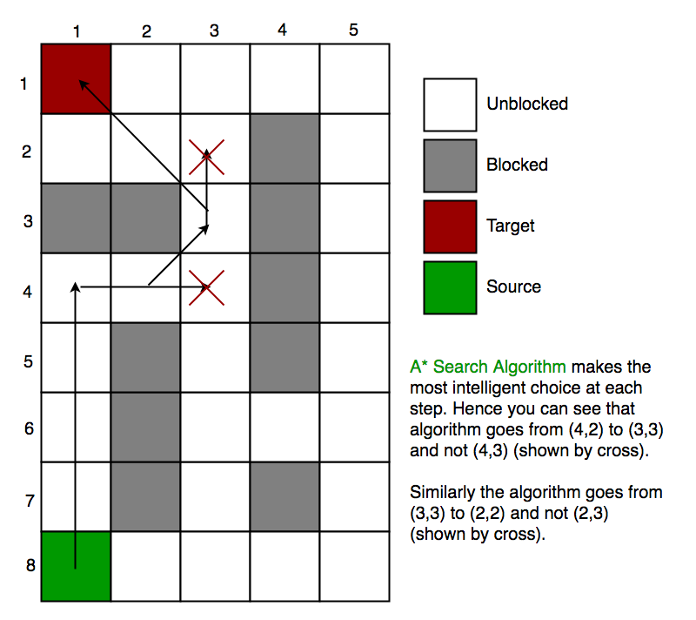

***Figure 11.*** *Visualization of A* Algorithm.*

Each step it picks the node according to a value - ‘f’ which is a parameter equal to the sum of two other parameters – ‘g’ and ‘h’. At each step it picks the node/cell having the lowest ‘f’, and process that node/cell. We define ‘g’ and ‘h’ as simply as possible below:

**g** = the movement cost to move from the starting point to a given square on the grid, following the path generated to get there.

**h** = the estimated movement cost to move from that given square on the grid to the final destination. This is often referred to as the heuristic, which is nothing but a kind of smart guess. The algorithm doesn’t know the actual distance until it finds the path, because all sorts of things can be in the way (walls, water, etc.).

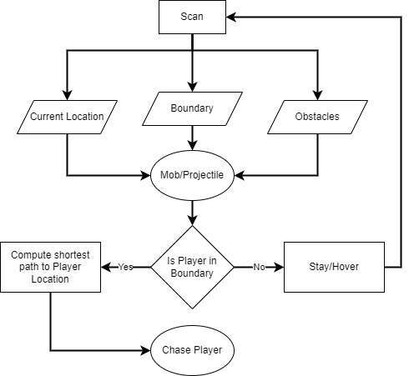

***Figure 12.*** Application of the pathfinding.

As shown in Figure X, the program will scan for the starting location, the movement boundary (to make sure that the movement will be localized to the designated area), and obstacles. If the player enters the vicinity of the boundary, the program will now start to find the shortest path to the target (the player) which will prompt the chase. If the player leaves the boundary, or is not present inside the boundary, the mob will either hover around or be stationary depending on its type, which will reset the process.

**Visuals**

As the game is 18th-19th century era inspired, the buildings, objects, and characters in the game mostly sport a vintage look, in exception to the main character and its contemporary enemies.

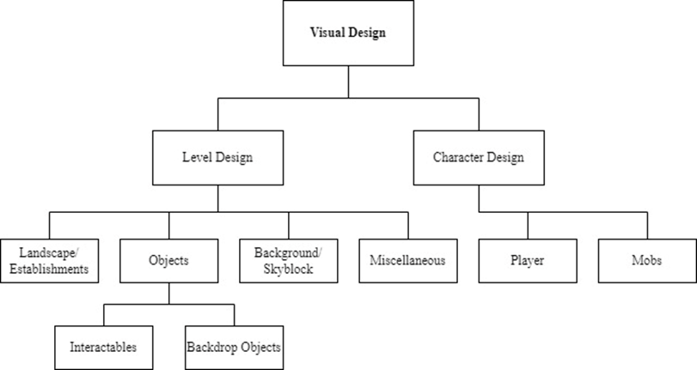

***Figure 13.*** Visual Table of Content Design

**A. Level Design** – The buildings in the game are wooden and stone establishments. The ground is mostly be unpaved roads and the background sports a lot of greeneries. The objects and obstacles present in the game are also vintage, mostly wooden things such as crates, carts, boats, furniture, etc.



***Figure 14.*** Escolta St., Manila in the 19th century. Buildings in the game are modeled after these kinds of establishments.

**B. Character Design** – With the exception of the main character and its adversaries, all the other characters/mobs seen in the game are dressed like people in the 18th-19th century. They generally wear vintage suits and dress for Spaniards, *barong tagalog* and *baro’t saya* for Filipino men and women, and appropriate vintage military attire for soldiers.

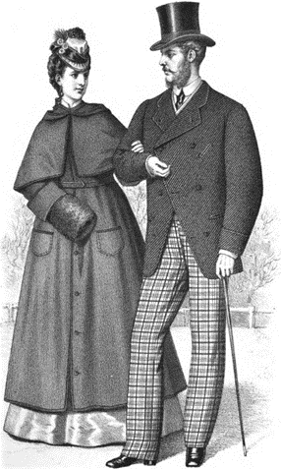

***Figure 15.*** 19th century European clothing (left), Barong at Saya (right)

**Assets**

Almost of the assets that are used in the game came from the Unity Asset Store, majority of which are free. There are also be assets that are made originally, specifically for certain levels that heavily features Filipino look to the setting and characters. The assets can be edited and created using Adobe Photoshop and Adobe Illustrator, since they are usually still images and illustrations.

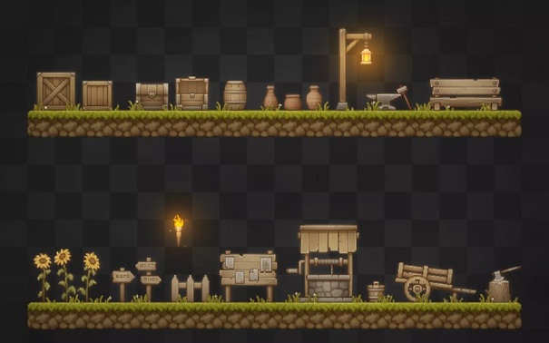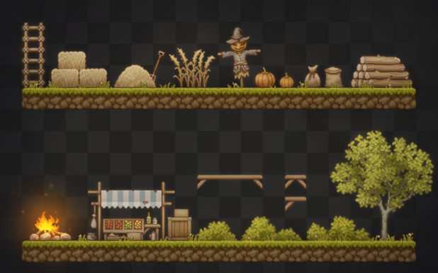

***Figure 16.*** Some of the assets used in the game.

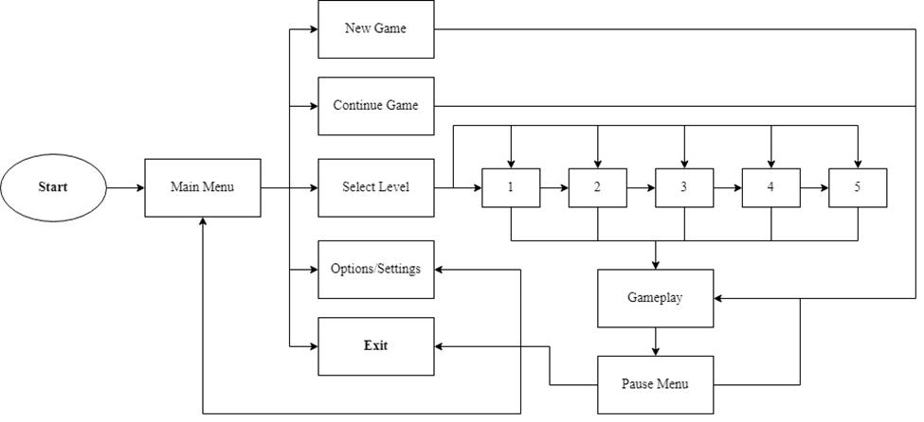***Figure 17.*** LAKBAY High-Level Interface Diagram

When the game boots up, the player will be greeted by a landing screen, prompting the user to press any key to continue to the Main Menu. The main menu will then feature five main options: New Game, Continue Game (if save game is available), Select Level, Settings, and lastly Exit. The new game option will overwrite any saved game progression and will start the game back to level 1. On the other hand, the continue game option will move the player to the last checkpoint/level played (if save game is available). Next is select level in which the user can choose what specific level he/she wants to play. This will also overwrite any saved game progression, and will start the game on the selected level. Then, the settings, where the user is able to customize the game experience. The user can adjust music volume, FX volume, resolution, and more. And lastly, the exit which will terminate the program and close the window. When the gameplay is ongoing, the user can prompt the pause menu, in which he/she can access the settings and exit, and can also go back to the Main Menu, saving the current progression of the game.

**Project Development**

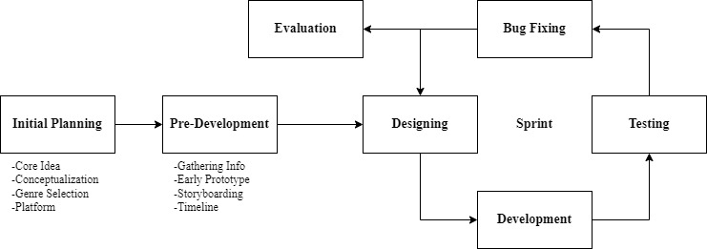

***Figure 18.***Agile Development Model of LAKBAY

The researchers utilized a method called agile methodology, in which the researchers have a goal set to finish in a specific timeframe. This allows the researchers to finish the divided tasks efficiently without losing quality, as the model specializes in incremental changes, in which every iteration is tested.

**Process**

* Initial Planning – In this phase, the researchers start with brainstorming different ideas to form the core idea of the game. This includes the selection of concept, genre and platform.
* Pre-Development – After the initial planning, the researchers gathered information based on the concept that has been decided. Which was then used to make an early prototype that contains basic mechanics.
* Sprint – Here the researchers divided the tasks and cycle through four phases: designing, developing, testing, and bug fixing. First, the researchers tackled game mechanics, which includes player movement, object interaction, and more. Next is modeling, where prefabs and assets are designed in order to make level designing easier. When all the models are finished, the researchers moved on to level designing, where five levels are designed individually. And lastly, for the finishing touches, are audio and visual assets that are added to the game to improve the overall aesthetic. Each task will be tested for bugs, and overall playability.
* Evaluation – After the sprint is done, the last part of the process is the evaluation, where the game is evaluated by the respondents.

**Operation and Testing Procedure**

**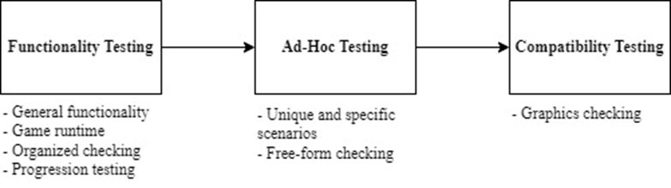*Figure 18.***Three-phase testing process

The operation and testing procedure was split in three phases, functionality testing, ad-hoc testing, and compatibility testing. First is the functionality testing, where the general functionality of the game is tested. Here the game is tested if it works according to the initial specifications, and the emphasis were on the basic elements that must be functional. Generally, the general graphics, UI, sound, and mechanical problems are checked. The game was also checked if it runs from start to finish without break. Second is the Ad-Hoc testing, where the game is tested with the sole purpose of finding bugs and errors. It is a free-form testing, meaning there is no checklists to follow. The difference in this testing is that the player intentionally did things that are not usually done in a normal gameplay in order to catch bugs that are not obvious but still game-breaking. Lastly, the final phase, compatibility testing. In this testing, the game is played in various screen sizes. This is to check if the game meets the essential requirements of the software, hardware, and graphics.

**Functional Testing** is performed to test the functionality of the features of the created game. It is done to ensure that each feature would function as expected. The following procedures are the steps that should be done to test the functionality of the game.

1. Identify the functions of each feature.

2. Check the input and output required for each specified feature.

4. Run the test cases.

5. Compare the test results from the expected results.

6. Evaluate the test results if it passed or failed.

A test case was used to record each test that was performed for each feature. Results were evaluated to check the functionality of the application.

**Table 1.**

*Test Case Form (Sample)*

|  |  |  |  |  |  |
| --- | --- | --- | --- | --- | --- |
| **Test Case ID** | **TCFT-01** | **UC Reference** |  | | |
| **Objective** | Press **Directional** keys set by the user in the game ie.( W = Jump, A = Left, D = Right). | | | | |
| **Assumptions/**  **Preconditions** | The game is running and the player’s character is on the field ready for user input. | | | | |
| **Actions** | **Expected Results** | | | | |
| 1. Press W | Player will jump. | | | | |
| 2. Press A | Player will move to the left. | | | | |
| 3.Press D | Player will move to the right | | | | |
| **Status** | Passed | **Severity** |  | **Priority** |  |

The table includes the following information:

1. Test Case ID, a number that uniquely identifies the test case;
2. UC Reference which indicates the required document reference that served as the case's basis;
3. Objective which specifies the test scenario;
4. Assumptions/Preconditions, which are the requirements that must be met prior to executing the test procedure;
5. Actions indicating the required steps to execute the test case;
6. Expected Output which outlines the anticipated outcome of the test; and
7. Actual Results that demonstrate if the application succeeded or failed the test case with the proper severity and priority marks.

**Table 2.**

*Functionality Testing Cases*

|  |  |  |
| --- | --- | --- |
| **Test ID** | **Objective** | **Expected Results** |
| TCFT-01 | Select Play Game in main menu | Player will proceed to level 1. |
| TCFT-02 | Select Level Select and choose a level in main menu | Player will proceed to corresponding selected level. |
| TCFT-03 | Press D, A, and W in keyboard | Player will move accordingly to the directional representation of pressed keys. |
| TCFT-04 | Press G in keyboard | If player is touching a chest, open, else, player fires projectile. |
| TCFT-05 | Press P in keyboard while in-game | Pause menu will appear and game timer will be paused. |
| TCFT-06 | Deplete all the player’s health points | Game Over screen will appear. |
| TCFT-07 | Select Retry in game over screen | The level that the player is currently on will reload. |
| TCFT-08 | Select Main Menu in game over screen | The player will be sent back to the main menu. |
| TCFT-09 | Reach the endpoint/end goal of a level | The game will load the next level. |
| TCFT-10 | Select Exit Game in main and pause menu | The game window will close. |

**Portability Testing**

After the functionality test, the game’s compatibility with different screen sizes. This testing is done in order to check if the game has the essential requirements to run in different devices with different screen resolutions and different Windows OS versions. The game is tested in the following resolutions and OS versions:

**Table 3.**

*Portability Testing*

|  |  |
| --- | --- |
| **Test ID** | **Screen Resolution** |
| TCCT-01 | 1920x1080 (16:9) |
| TCCT-02 | 1366x768 (16:9) |
| TCCT-03 | 1280x720 (16:9) |
| TCCT-04 | 1024x768 (4:3) |
| TCCT-05 | 800x600 (4:3) |
| **Test ID** | **Windows OS Version** |
| TCCT-01 | Windows 7 (64-bit) |
| TCCT-01 | Windows 8 (64-bit) |
| TCCT-01 | Windows 10 (64-bit) |
| TCCT-01 | Windows 11 (64-bit) |

**Evaluation Procedure**

The developed game is evaluated using the criteria of ISO 25010 for Software Product Quality. LAKBAY is evaluated by 30(?) randomly selected respondents composed of students. The evaluation procedure is as follows:

1. Each respondent is provided an assessment form that is used to evaluate the game.
2. The researchers held a short demonstration of how the system works, and discuss the functions, features, and objectives of the game.
3. The respondents are asked to play the game.
4. After playing the game, the respondents are asked to evaluate the game through the assessment form according to ISO 25010.
5. The overall mean rating for each criterion is calculated based on the collected data.
6. The results are evaluated using the mean values in table X and the qualitative interpretation corresponding to that value.

**Table 4**

*Four-Point Likert Scale*

|  |  |
| --- | --- |
| **Numerical Rating** | **Adjectival Interpretation** |
| 4 | Highly Acceptable |
| 3 | Very Acceptable |
| 2 | Acceptable |
| 1 | Not Acceptable |

**Table 5**

*The Range of Weighted Mean Ratings and its Qualitative Representation*

|  |  |
| --- | --- |
| **Numerical Rating** | **Qualitative Interpretation** |
| 3.4 - 4.0 | Very Good |
| 2.6 - 3.3 | Good |
| 1.8 - 2.5 | Fair |
| 1.0 - 1.7 | Poor |

**Chapter 4**

**RESULTS AND DISCUSSIONS**

This chapter presents the project description, project structure, project test results, project capabilities and limitations, and project evaluation results of the study.

**Project Description**

LAKBAY, a 2D platform game based off of Philippine history for the PC, is designed to give its players a fun and interesting way to interact with history. This PC game allows its players to learn Philippine history through different means and through a more entertaining medium. It features 5 levels with a plot involving Philippine history, and a playable main character that interacts with item chests, and power ups in order to defeat enemies and complete the levels.

The PC game currently supports computers running at least Windows 7 or above. The application was developed using Unity Game Development for most of the development, which uses C# for most of the backend code such as the physics of the characters within the game.

**Project Structure**

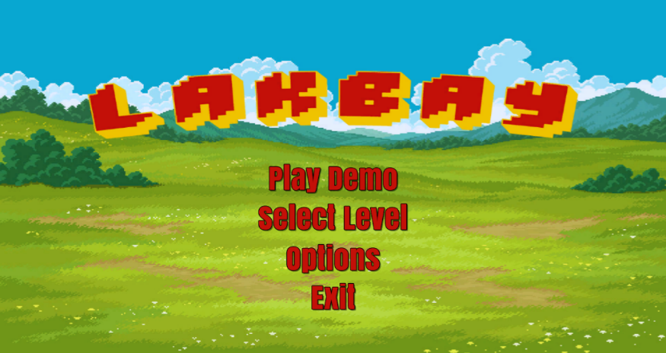

***Figure 12:*** LAKBAY Main Menu

Figure 12 shows the landing screen. This is the first thing the player sees when the player opens up the game. The player is greeted by a Main Menu with four options: Play Game – which will automatically load the player into the very first scene and stage; Select Level – where the player can choose which level/stage they want to play; Options – where the sound effects and music settings are found; and lastly Exit – which exits the game and closes the program.

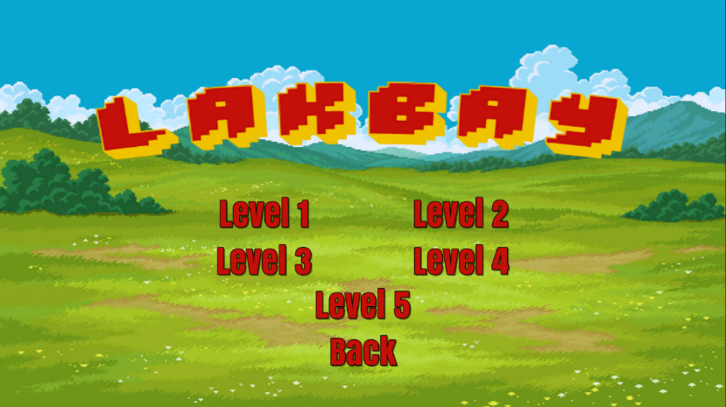

***Figure 13:*** Select Level Screen

Figure 13 shows the Select Level screen, this screen allows the player to select which level they want to play without having to start from the beginning all the time. Once the player picks, the game will load the corresponding level bypassing the ones before it.

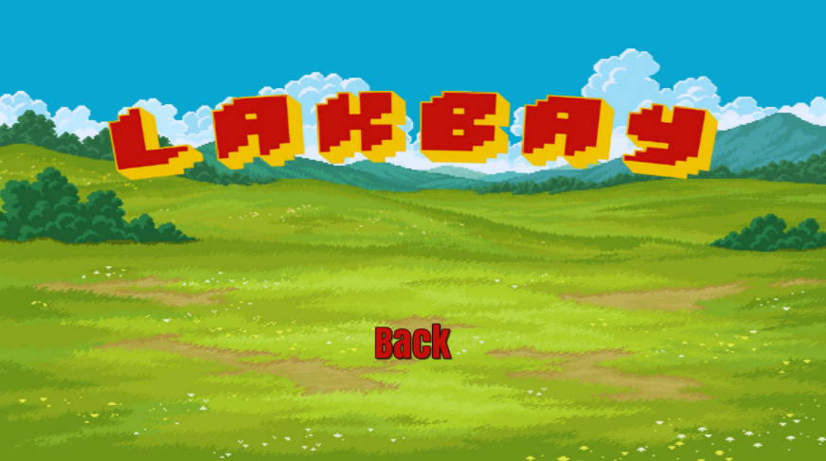

**Figure 14: Options Screen**

Figure 14 presents the Options screen to the user. This screen gives the user the ability to fix aspects of the game to their liking. The option menu features a sound effects and music switch, which they can turn on/off.

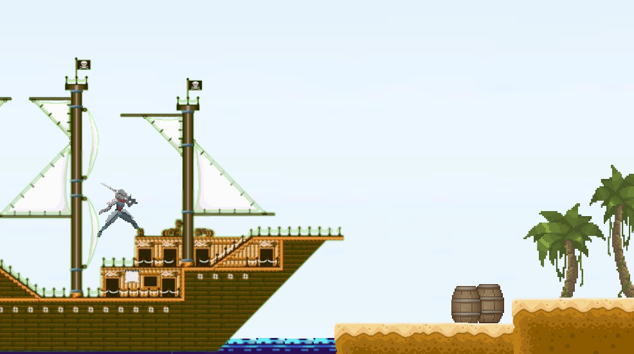

**Figure 15: Level 1**

Figure 15 shows the landing spot of the first level of the game. The player is spawned on a big wooden ship, representing Trinidad, one of Magellan’s Ships. The level is mostly set on an island and coastline setting, where the ground is sand, and the trees are exclusively palm.

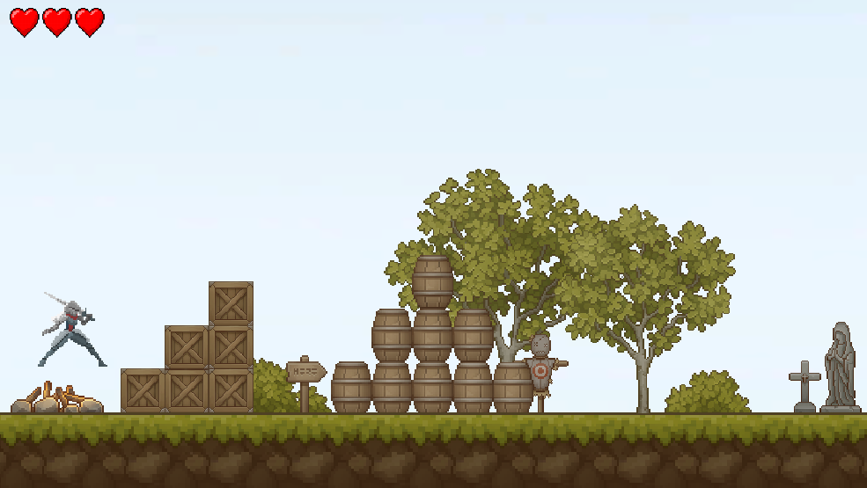

**Figure 16: Level 2**

Figure 16 shows the Second playable level: Level 2 – Sandugo. The level is set on the inside the island of Bohol. Here, vegetation is noticeably greater than the previous level, the reason being this is inside of the island. The level also features lots of wooden furniture, houses and other Spanish Era things as decoration.

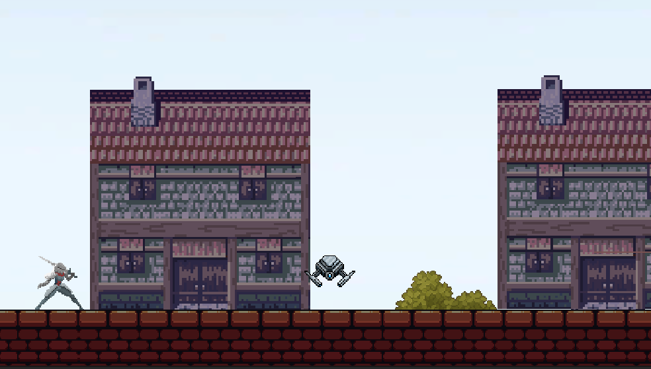

**Figure 17: Level 3**

Figure 17 shows the third playable level: Level 3 – First Print of Jose Rizal’s Noli Me Tangere. Unlike the earlier two, the story of Level 3 is set on the city of Berlin, Germany. The environment is noticeably much more different than the first two because of the fact that at the time, Berlin is much more advanced than the Visayas islands, showcasing brick houses, stone infrastructure, and paved roads. Overall, the level sports a more industrial look.

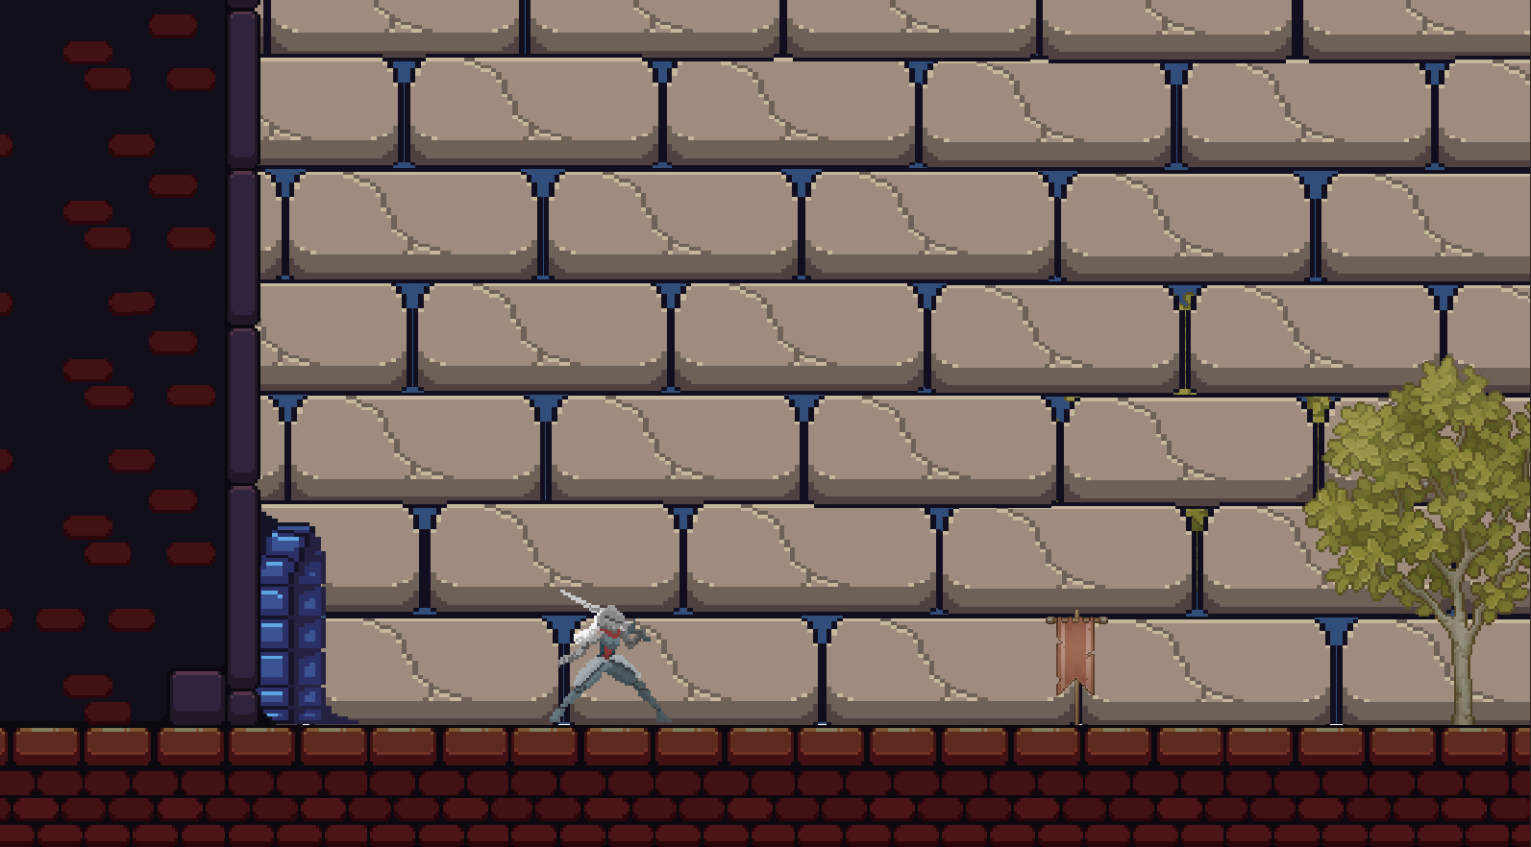

**Figure 18: Level 4**

This figure shows the 4th level in our game, the Execution of Rizal set in Intramuros. The objective of this level is to make sure that the Execution of Rizal happens on the day and time as history has it. The entirety of the level is covered by a massive wall in the background, similar to the aesthetic of the Walled City of Intramuros.

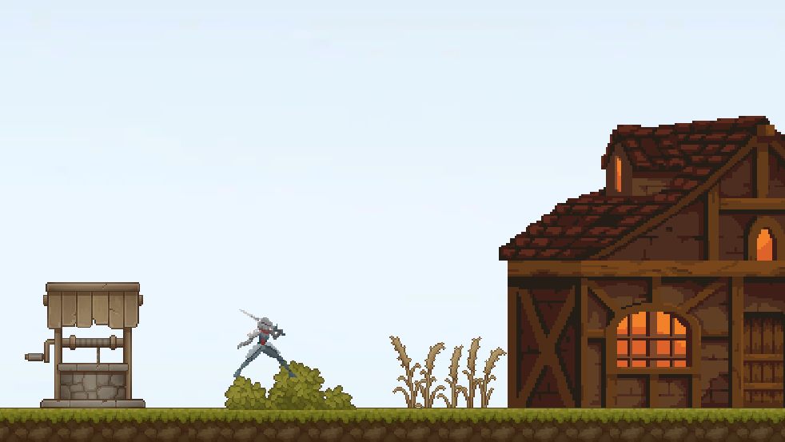

**Figure 19: Level 5**

Figure 19 shows the starting point for the last level in LAKBAY: Level 5 - The Treaty of Paris. The story is set on the countryside of France, showcased by the unpaved roads, almost farmland looking setting, and presence of wheat in the background. The objective of this final level is to stop the Villain from keeping the Treaty Papers into reaching the capital, Paris.

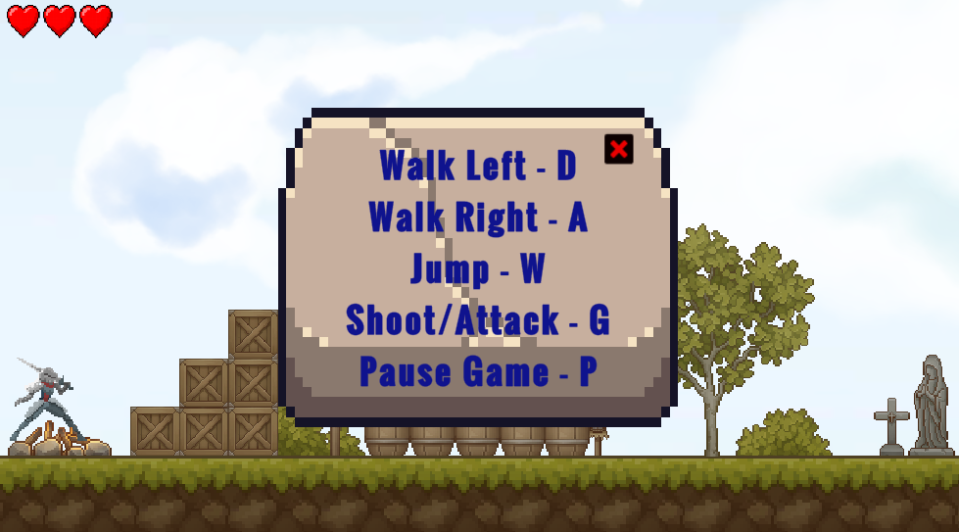

**Figure 20: Example of the Instruction/Objective Panel**

Figure 20 shows an example of an instruction or objective panel, which is always shown at the start of every level. Inside the panel are clues about the objective, the story behind the objective, and other important details about the level or mission.

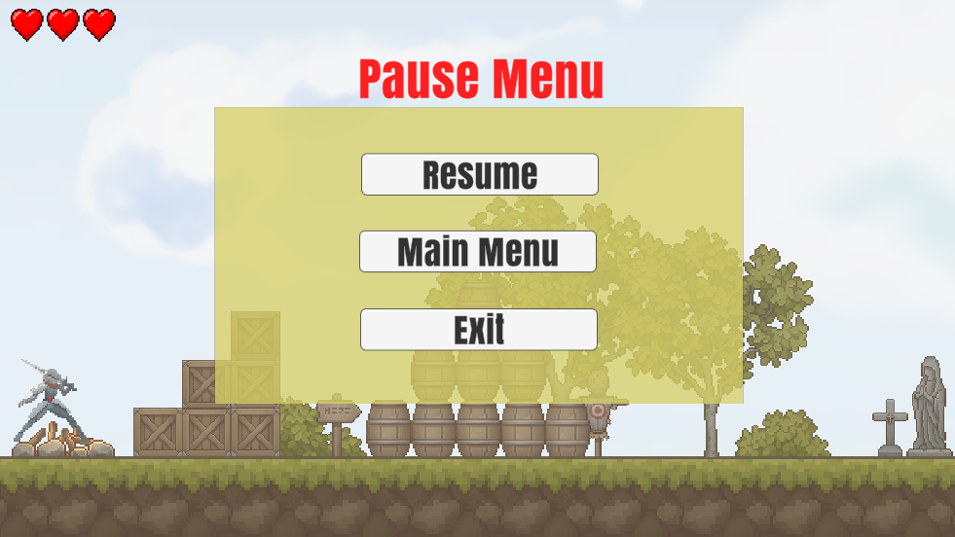

**Figure 21: Pause Menu**

Figure 21 shows the Pause Menu in the game. The pause menu features three options; Resume – which resumes the game timer and the user’s gameplay; Main Menu – which sends the player back into the main menu; and lastly, Exit – which exits the current level, and closes the program.

**Project Test Results**

This section summarizes the test results executed and the data collected based on the functionality, reliability, portability, and usability testing.

Table #.

*Functionality Test Summary*

|  |  |  |  |
| --- | --- | --- | --- |
| **Test Execution** | **Expected Results** | **First Test Results** | **Second Test Results** |
| No. of Test Cases Executed | 10 | 10 | 10 |
| Passed | 10 | 9 | 10 |
| Failed | 0 | 1 | 0 |
| Success Rate | 100% | 90% | 100% |

Table # summarizes the conducted functionality test results. The table shows that out of 10 test cases (see chapter 3 - page 69 for reference), all 10 were run. In the first test, out of the 10 test cases ran by the researchers, 9 were successful, and 1 failed, resulting into 90% success rate. After some bug fixing and cleaning up, the second test was run. Out of the 10 test cases ran by the researchers, 10 were successful, and none failed, resulting into 100% success rate.

Table #.

*Portability Test for Screen Resolution Adaptability Summary*

|  |  |  |  |
| --- | --- | --- | --- |
| **Test Case ID** | **Aspect Ratio** | **Screen Resolution** | **Result** |
| TCCT-01 | 16:9 | 1920x1080 | Success |
| TCCT-02 | 16:9 | 1366x768 | Success |
| TCCT-03 | 16:9 | 1280x720 | Success |
| TCCT-04 | 4:3 | 1024x768 | Success |
| TCCT-05 | 4:3 | 800x600 | Success |
|  | **Resolutions Tested** | **Failure Count** | **Success Count** |
| **Total** | 5 | 0 | 5 |

Table # summarizes the conducted compatibility test results. The table shows all the screen resolutions tested in the procedure alongside its corresponding aspect ratio. The result shows that the game is compatible to all five of the screen sizes and aspect ratios tested, resulting in a 100% success rate.

Table #.

*Portability Test for Installability Summary*

|  |  |  |  |
| --- | --- | --- | --- |
| **Test Case ID** | **Type** | **Windows OS Version** | **Result** |
| TCCT-01 | 64-bit | Windows 7 | Success |
| TCCT-02 | 64-bit | Windows 8 | Success |
| TCCT-03 | 64-bit | Windows 10 | Success |
| TCCT-04 | 64-bit | Windows 11 | Success |
|  | **Versions Tested** | **Failure Count** | **Success Count** |
| **Total** | 4 | 0 | 4 |
|  |  |  |  |

Table # summarizes the conducted portability test results for the game’s installability within different versions of Windows OS. The table shows all the versions tested in the procedure alongside its corresponding bit type. The result shows that the game is compatible to all four of the versions tested, resulting in a 100% success rate.

**Project Capabilities and Limitations**

The following are the capabilities of the system:

1. The game is capable of running in machines and Windows operating systems that are not as recent or up to date.

2. The game can showcase how a simple 2D game can bring entertainment and joy to its players.

3. This game lets the user learn about history in a new and more entertaining way, through a video game.

4. This game can be played offline and does not need an internet connection to save progress.

The following are the limitations of the system:

1. The game only has 5 playable levels due to the time constraint of this project.

2. This game has limited room for customizability as it is a story game and does not have a need for different cosmetics.

3. This game only has one playable character throughout the entire game.

4. The application can only be run on Windows systems from Windows 7 to the most recent Windows 11.

**Project Evaluation Results**

The evaluation procedure was conducted using the standard criterion of ISO 25010 to check for the quality of the software. The following are the results of the evaluation on the LAKBAY PC game:

Table #.

*Overall Evaluation Results Summary*

|  |  |  |
| --- | --- | --- |
| **Criteria** | **Mean Average** | **Qualitative Interpretation** |
| Functional Stability | 3.46 | Very Good |
| Performance Efficiency | 3.48 | Very Good |
| Portability | 3.52 | Very Good |
| **Total** | **3.49** | **Very Good** |

Table # summarizes the overall evaluation results based on the ISO 25010 standards. It shows the weighted mean per criterion and its equivalent qualitative interpretation. The table shows that the game’s score for functional stability is 3.46, performance efficiency score of 3.48, and portability score of 3.52, all of which translates to a qualitative interpretation of very good. The overall mean average score of the game is 3.49, which is a very good qualitative interpretation. The specifics and scores of each criterion questions showed are further discussed in the figures below.

**A. Functional Suitability**

Forms response chart. Question title: I. FUNCTIONAL SUITABILITY

This attribute indicates the extent to which a product or system offers features that fulfill explicit and implicit requirements when utilized within defined circumstances.
. Number of responses: .

***Figure #.*** Functional Suitability Scores

Figure # shows the graph for the evaluation results of functional suitability. The game was evaluated very good by the respondents, with an overall mean score of 3.46, which implies that the application meets the functions stated and needs implied under specification conditions. The figures below show the questions, scores, and the number of respondents that graded the said score for the criterion functional suitability.

***Figure #.*** Functional Suitability Question 1

***Figure #.*** Functional Suitability Question 2

***Figure #.*** Functional Suitability Question 3

Table #.

*Functional Suitability Results Summary*

|  |  |  |
| --- | --- | --- |
| **Criteria** | **Mean Average** | **Qualitative Interpretation** |
| Question 1 | 3.47 | Very Good |
| Question 2 | 3.43 | Very Good |
| Question 3 | 3.47 | Very Good |
| **Total** | **3.46** | **Very Good** |

**B. Performance Efficiency**

Forms response chart. Question title: II. PERFORMANCE EFFICIENCY

This attribute refers to the efficiency of the performance of the system in relation to the resources utilized when operating within specified conditions.
. Number of responses: .

***Figure #.*** Performance Efficiency Scores

Figure # shows the graph for the evaluation results of performance efficiency. The game was evaluated very good by the respondents, with an overall mean score of 3.48, which implies that the game quickly responds and execute its function within acceptable response time. The figures below show the questions, scores, and the number of respondents that graded the said score for the criterion performance efficiency.

***Figure #.*** Performance Efficiency Question 1

***Figure #.*** Performance Efficiency Question 2

***Figure #.*** Performance Efficiency Question 3

Table #.

*Performance Efficiency Results Summary*

|  |  |  |
| --- | --- | --- |
| **Criteria** | **Mean Average** | **Qualitative Interpretation** |
| Question 1 | 3.4 | Very Good |
| Question 2 | 3.57 | Very Good |
| Question 3 | 3.47 | Very Good |
| **Total** | **3.48** | **Very Good** |

**C. Portability**

Forms response chart. Question title: III. PORTABILITY

This attribute refers to the ease and efficacy with which a system, product, or component can be adapted to a different hardware, software, or operating environment.
. Number of responses: .

***Figure #.*** Portability Scores

Figure # shows the graph for the evaluation results of performance efficiency. The game was evaluated very good by the respondents, with an overall mean score of 3.52, which implies that the game quickly responds and execute its function within acceptable response time. The figures below show the questions, scores, and the number of respondents that graded the said score for the criterion portability.

***Figure #.*** Performance Efficiency Question 1

***Figure #.*** Performance Efficiency Question 2

***Figure #.*** Performance Efficiency Question 3

Table #.

*Portability Results Summary*

|  |  |  |
| --- | --- | --- |
| **Criteria** | **Mean Average** | **Qualitative Interpretation** |
| Question 1 | 3.53 | Very Good |
| Question 2 | 3.67 | Very Good |
| Question 3 | 3.37 | Good |
| **Total** | **3.52** | **Very Good** |

**Chapter 5**

**SUMMARY OF FINDINGS, CONCLUSIONS, AND RECOMMENDATIONS**

This chapter presents the summary of findings, conclusions, and recommendations based from the results of the evaluation, comments, and suggestions.

**Summary of Findings**

On the basis of tests and evaluations conducted on the performance capability of the application, the following were the findings of the study:

The game was developed according to the planned design and specifications, including the story, game elements, visual design, and game mechanics. The game gives the users a learning experience as a part of playing the game that can help ignite their thirst for learning more about the intricacies of what really happened outside of the story presented in the game. The game also gives a good balance of difficulty and fun in its gameplay that is suitable for any range of age. The application also underwent testing and passed using the criteria or principles of ISO 25010. This implies that the application can be easily be used, adapted, and installed by any users.

Based on the data gathered during the project evaluation, the study got an overall rating of 3.49 with a corresponding qualitative interpretation of very good. Particularly the study obtained:

* In terms of functionality suitability, the software was rated good which means that the objectives had been accomplished to its intended purpose and function.
* In terms of performance efficiency, the software was rated good which proves that the application quickly responds and execute its function within acceptable response time.
* In terms of portability, the software was rated good which proves that the application can be installed and run on Windows 7/8/10/11 devices.

**Conclusions**

In consideration of the objectives of the study and the results of the testing and evaluation undertaken, the following conclusions were derived:

1. The LAKBAY: History Themed 2D Adventure Game was successfully designed with the following features:

1. Single player game.
2. Simple and classic 2D-game control settings.
3. Vintage setup of environment, platforms, structures, items, and sound effects.
4. Five story levels with different objectives or task inspired by events that happened in Spanish Colonial era of the Philippines.
5. Acquire power-ups like improve jump height, ability to shoot projectiles, and boost running speed.
6. Uses A* pathfinding algorithm to the movement of the NPCs in the game for pathfinding.

2. The game was created using the following tools:

# a. Hardware:

# Laptop/Desktop Computer

# At least Windows 8 OS

# At least 4GB RAM

# AMD Ryzen 3 or Intel i3 equivalent

# b. Software:

# Unity Game Developer

# Adobe Photoshop/Illustrator

# Visual Studio Code

3. The functionality, performance efficiency, and portability of the game were tested and successfully improved.

4. The application performance was completely evaluated using ISO 25010 criteria and yielded an overall mean of 3.49.

**Recommendations**

Considering the findings and conclusions made in the study, the following recommendations for the improvement of the application are hereby presented for future enhancement:

1. Develop a mobile version for better availability.

2. Improvisation of sounds, visuals and user interface for better user experience.

3. Creation of more diverse options for mobs/enemies and in-game features like moving platforms or terrains.

4. Addition of more levels and storyline from other eras in the past.

# REFERENCES

Bhosale, T., Kulkarni, S., & Patankar, S. N. (2018). 2D Platformer Game in Unity Engine. International Research Journal of Engineering and Technology, 5(04), 3021-3024.

Minkkinen, Toni. "Basics of Platform Games." (2016).

Khalifa, Ahmed, Fernando de Mesentier Silva, and Julian Togelius. "Level design patterns in 2D games." 2019 IEEE Conference on Games (CoG). IEEE, 2019. doi:10.1109/cig.2019.8847953

Brenner-Adams, R. Teaching with video games: Observations on tutorials and gameplay. Diss. 2017.

Boom, Krijn HJ, et al. "Teaching through play: Using video games as a platform to teach about the past." Communicating the Past in the Digital Age. Proceedings of the International Conference on Digital Methods in Teaching and Learning in Archaeology (12th -13th October 2018). Ubiquity Press, 2020.

El-Habr, Camille, et al. "Runner: A 2D platform game for physical health promotion." SoftwareX 10 (2019): 100329.

Melcer, Edward F., and Marjorie Ann M. Cuerdo. "Death and rebirth in platformer games." Game User Experience And Player-Centered Design. Springer, Cham, 2020. 265-293.

Choi, E., Shin, S.-H., Ryu, J.-K., Jung, K.-I., Kim, S.-Y., & Park, M.-H. (2020). Commercial video games and cognitive functions: video game genres and modulating factors of cognitive enhancement. Behavioral and Brain Functions, 16(1). doi:10.1186/s12993-020-0165-z

Zirawaga, Victor Samuel, Adeleye Idowu Olusanya, and Tinovimbanashe Maduku. "Gaming in education: Using games as a support tool to teach history." Journal of Education and Practice 8.15 (2017): 55-64.

Cam, Lien, and Thi Minh Thu Tran. "An evaluation of using games in teaching English grammar for first year English-majored students at Dong Nai Technology University." International journal of learning, teaching and educational Research 16.7 (2017): 55-71.

Smith, G., Cha, M., & Whitehead, J. (2008). A framework for analysis of 2D platformer levels. Proceedings of the 2008 ACM SIGGRAPH Symposium on Video Games - Sandbox ’08. doi:10.1145/1401843.1401858

Bostan, Barbaros, ed. Game User Experience and Player-Centered Design. Istanbul: Springer, 2020.

1Subhash, Sujit, and Cudney, Elizabeth. "Gamified learning in higher education: A systematic review of the literature." Computers in Human Behavior, vol. 87, 2018, pp. 192-206, <https://doi.org/10.1016/j.chb.2018.05.028>.

Kuo, Ming, and Chuang, Tsung. "How gamification motivates visits and engagement for online academic dissemination – An empirical study." Computers in Human Behavior, vol. 55, 2016, pp. 16-27, <https://doi.org/10.1016/j.chb.2015.08.025>.

Alsadoon, Elham, et al. "Effects of a gamified learning environment on students’ achievement, motivations, and satisfaction." Heliyon, vol. 8, no. 8, 2022, p. e10249, <https://doi.org/10.1016/j.heliyon.2022.e10249>.

Kirkman, Kaitlin. "Educational Games: A Basic Understanding and Effective Uses - CORE Reader." 1 May. 2020 <https://core.ac.uk/reader/322921815>

Andrew, J., et al. "Analyzing the factors that influence learning experience through game based learning using visual novel game for learning pancasila." Procedia Computer Science 157 (2019): 353-359.

Anastasiadis, Theofylaktos, Georgios Lampropoulos, and Kerstin Siakas. "Digital game-based learning and serious games in education." International Journal of Advances in Scientific Research and Engineering 4.12 (2018): 139-144.

Taub, Michelle, et al. "The agency effect: The impact of student agency on learning, emotions, and problem-solving behaviors in a game-based learning environment." Computers & Education 147 (2020): 103781.

Toquero, Cathy Mae Dabi, et al. "Game-based learning: Reinforcing a paradigm transition on pedagogy amid COVID-19 to complement emergency online education ." International Journal of Didactical Studies, vol. 2, no. 2, 2021, 6 Jun. 2021 https://www.ijods.com/download/game-based-learning-reinforcing-a-paradigm-transition-on-pedagogy-amid-covid-19-to-complement-10969.pdf, 10.33902/IJODS.2021269730. Accessed 1 Jan. 1970.

Godoy Jr, Carlo. "A Review of Game-based Mobile E-Learning Applications." arXiv, 2021, https://doi.org/10.25147/ijcsr.2017.001.1.45. Accessed 21 Dec. 2022.S

Harris, C.A, Mong, C.J, & Watson, W.R.. A Case Study Of The In-Class Use Of a Video Game For Teaching High School History (2011)

Bourgonjon, J., Et Al Acceptance Of Game-based Learning By Secondary School

Teachers (2013)

Robson, D., Rodriguez, A., & Sassen, C., Advances In Academic Video Game

Collections (2020)

Hooshyar, D., Et Al. An Adaptive Educational Computer Game: Effects On Students’

Knowledge And Learning Attitude In Computational Thinking (2021)

Chang, W., Chao, L.r., Chen, J., Shih, T., & Wang, T. Developing An Interactive Video

Game-based Learning Environment (2009)

Gede Putra Kusuma Et Al. Enhancing Historical Learning Using Role-playing Game On

Mobile Platform (2021)

Sharritt, M.J. Forms Of Learning In Collab (2008) Admiraal, W., Et Al. Learning History

By Playing A Mobile City Game (2018)Ardito, C,. Et Al. Making Dead History

Come Alive Through Mobile Game-play (2019)

Dave, A. (2022, December 5). *Why Choose Unity 3D for Your Next Game Development Project?* Mindinventory. https://www.mindinventory.com/blog/unity-3d-game-development/

Moh Rizaldi. (2017). Design and Implementation Visual Environment of 2D Puzzle Platformer Computer Game: ASCENDER. *International Journal of Asian Art and Design*. https://www.jstage.jst.go.jp/article/adada/21/1/21_73/_pdf

Md Shukri, M. R., & Ariffin, S. A. (2019). The development process of Awang sains 2D digital mobile game. *Journal Of ICT In Education*, *6*, 28-36.<https://doi.org/10.37134/jictie.vol6.3.2019>

Rafiq, A., Asmawaty Abdul Kadir, T., & Normaziah Ihsan, S. (2020). Pathfinding algorithms in game development. *IOP Conference Series: Materials Science and Engineering*, *769*(1), 012021. https://doi.org/10.1088/1757-899x/769/1/012021